KIJISET 2022
Kenya Certificate of Secondary Education

FORM 4 TERM 2
121/1–MATHEMATICS –Paper 1
ALT A
Jun. 2022 – 2 ½ hours
Name: ………………………………………………………………..…. Index Number: ………………….…………..
Candidate’s Signature: ……………………………………………… School................................................

Instructions to Students
- Write your name and Admission number in the spaces provided above.
- Sign and write the date of examination in the spaces provided above.
- This paper consists of two sections: Section 1 and section II.
- Answer ALL question in section I and only five questions from section II.
- Show all the steps in your calculations, giving your answers at each stage in the spaces below each question.
- Marks may be given for correct working even if the answer is wrong.
- Non-programmable silent electronic calculators and KNEC mathematics tables may be used, except where stated otherwise.

For Examiner’s Use Only
Section I
1 | 2 | 3 | 4 | 5 | 6 | 7 | 8 | 9 | 10 | 11 | 12 | 13 | 14 | 15 | 16 | Total

Section II
17 | 18 | 19 | 20 | 21 | 22 | 23 | 24 | Total |  |  | Grand Total

SECTION I
- Without using a calculator evaluate: (3Mks)
-2(5+3) – 9 ÷ 3 + 5
-3x -5 + -2 x 4

- A forex bureau in Nairobi Kenya buys and sells foreigh currency at rates shown below.
 | Buying in Ksh. | Selling in Ksh.
Euro | 129.80 | 131.60
UAN Dirhams | 28.40 | 29.80

A Belgian tourist arrived in Nairobi, Kenya with 5000Euros. She converted the whole amount to local currency. While in Kenya she spent Ksh.321200 and changed to UAE Dirhams before leaving for Dubai. Calculate the amount in UAE Dirhams that she received. (3Mks)

- Solve the following linear inequalities and represent the solution on a number line. (3Mks)
3x + 1≥10
2(x-1) 8x - 32

- Without mathematical tables or a calculator, evaluate (3Mks)

27^{⅔} x (81/16)^{-⅟}₄

- The mass of a solid cone of radius 14cm and height 18cm is 4.62kg. Find its density in g/cm³ ⁽Take ∏ = 22/7. (3Mks)

- Two similar solids have masses of 80kg and 270kg. Find the area of the larger solid if the smaller solid has a surface area of 48cm². (3Mks)

- Simplify
3x² – 2xy – y² (3Mks)
9x² – y²

- Use the prime factors of 1764 and 2744 to evaluate (3Mks)
$$\sqrt{1765}$$
$$\sqrt[3]{2744}$$

- The sum of interior angles of a regular polygon is 1800. Find the size of each exterior angle. (3Mks)

- The line y=mx+6 makes an angle of 75⁰58’ with X-axis. Find the coordinates of the point where the line cuts the x-axis. (3Mks)

- A two digit number is made by combining any 2 of the digits 1,3,5,7,9 at random.
- Make an array of possible combination. (2Mks)

- Find the probability that the number is a prime number. (2Mks)

- Under enlargement, the images of points A(3,1) and B(1,2) are A’(3,7) and B’(7,5). Without construction, find the centre and the scale factor of enlargement. (4Mks)

- Using a ruler and a pair of compasses only,
- Construct triangle ˂BAC in which BC=8cm, angle ABC=112½⁰ and BAC =45⁰ (2Mks)

- Drop a perpendicular from A to meet CB produced at P, hence find the area of triangle ABC. (2Mks)

- Use logarithms to evaluate (4Mks)

$$\sqrt[3]{\log{45.08}}$$
45.73 x 0.56

- Given that x is an acute angle and cos x⁰ = ⅖$\sqrt{5 , }$find without using mathematical tables or a calculator, tan (90-x)⁰.
⅖$\sqrt{5}$ (2Mks)

- Given that OA=2i+3j and OB=3i-2j, find the magnitude of AB to one decimal place. (2Mks)

SECTION II (50 MARKS)
- Given that y=7-3x-2x² for -4≤x≤3
- Complete the table below (2Mks)
X | -4 | -3 | -2 | -1 | 0 | 1 | 2 | 3
Y | 7 | 7 |  | 7 | 7 | 7 |  | 7
-2x | 12 | 9 |  | 3 | -0 | -3 |  | -9
-2x² | -32 | -18 |  | -2 | 0 | -2 |  | -18
Y | -13 | -2 |  | 8 | 7 | 2 |  | -20

- Draw the graph y = 7-3x – 2x² for -4≤x ≤3 (3Mks)

( c ) Use the graph to find the roots of the equation.
- -2x² - 3x + 7 = 0 (2Mks)

- -2x² – 4x + 9 = 0 (3Mks)

- A class of 36 students sat for a mathematics test which was marked out of 100 with individual marks shown below.

46 20 51 76 36 41 25 40 48
65 64 28 59 32 72 72 58 64
75 76 54 68 75 61 52 86 58
36 33 72 29 59 35 91 64 75
- Draw a frequency distribution table starting with 20 – 29 class (3Mks)

- State the modal class (1Mk)

(c ) Calculate the mean mark for the students. (3Mks)

(d)Calculate the median mark (3Mks)

- Kimaeti is a town centre 600km from Nairobi city. A bus starts from Nairobi for Kimaeti at 7.00am at an average speed of 80km/h. At 8.30am a car started from Nairobi to Kimaeti and moved at an average speed of 120km/hr using the same route. Calculate;
- The distance covered by the bus before the car started its journey. (3Mks)

- The relative speed for the two vehicles. (2Mks)

- The time the car overtook the bus: (1Mk)

- Distance covered by the car before overtaking the bus. (2Mks)

- Distance from Kimaeti to the car at the time the car was overtaking the bus.

- (a) Given that A =( 3 x) and B = ( 1 2)
X+1 2 3 0
Find the values of x for which AB is singular matrix. (4Mks)

(b) Siboti bought 3 exercise books and 5 pens for a total of Ksh. 165. If Siboti had bought 2 exercise books and 4 pens, he would have spent Ksh. 45 less. Taking x to represent the price of an exercise book and y to represent the price of a pen.
(i) form two equations to represent the above information (1Mk)

ii)Use matrix method to find the price of an exercise book and that of a pen. (3Mks)

(iii) A teacher of a class of 36 students bought 2 exercise books and 1 pen for each
student. Calculate the total amount of money the teacher paid for the books and pens. (2Mks)

- The figure below shows a stump of wood of height 16cm. The bottom and top radii are 10.5cm and 7cm respectively.
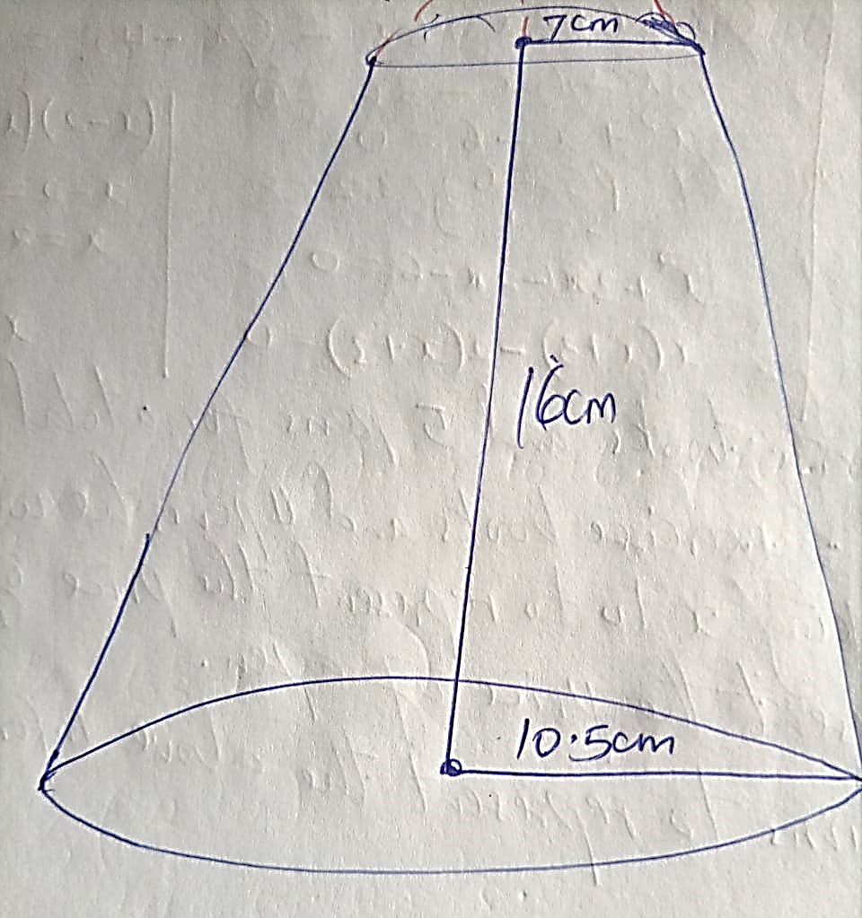

Calculate:
- The slant height of the smaller cone that was cut off to form the stump. (2Mks)

- The curved surface area of the stump. (4Mks)

- The volume of the stump. (4Mks)

- A particle moves a long straight line such that its displacement S metres from a given point is S=2t³ – 4t² + 2t + 6 where t is time in seconds. Find;
- The displacement of the particle at t=3. (2Mks)

- The velocity of the particle when t =5 (3Mks)

( c ) The values of t when the particle is momentarily at rest. (3Mks)

d) The acceleration of the particle when t = 2. (2Mks)

- (a) Complete the table below for the function y=x² – 3x + 6 in the range -2≤x≤ 8. (y=x²-3x+6)

X | -2 | -1 | 0 | 1 | 2 | 3 | 4 | 5 | 6 | 7 | 8
Y

(b)Use the trapezium rule with 10 steps to estimate the area bounded by the curve, y = x²-3x+6, the lines x=-2, x=8, and the x-axis. (3Mks)

c) Use the mid-ordinate rule with 5 strips to estimate the area bounded by the curve, y=x² – 3x + 6, the lines x=-2, x=8, and the x-axis. (2Mks)

d) By integration, determine the actual area bounded by the curve
y=x² – 3x + 6, the lines x = -2, x = 8, and x – axis. (3Mks)

- A safari rally competition has four check points A, B, C and D. Check point B is on a bearing of N 75⁰E from check point A at a distance of 34km. Check point C is on a bearing of 570⁰E from check point B at a distance of 20km. Check point A is on a bearing of 330⁰ from Check point D and Check point C is on a bearing N40⁰E of D. Using a scale of 1:500,000.
- Find the relative position of A, B, C and D. (5Mks)

- Find the distance of;
- D from A (1Mk)

- C from D (1Mk)

c) Determine;
(i) The compass bearing of A from D (2Mks)

(ii)The true bearing of D from B. (1mk)

