NAME;……………………………………..ADM…………….CLASS:……

GEOGRAPHY PAPER 1
FORM 3
END TERM 2, 2021
TIME:2³/₄ HOURS.

INSTRUCTIONS TO CANDIDATES
- This paper has two sections A and B.
- Answer Question 6 and any other two questions from section B.
- All answers must be written on the foolscaps provided.
- Students should check the question paper to ascertain that all the pages are printed as indicated and that no question is missing.
- Students should answer the questions in English.

- For examiner’s use Only.

Section | question | Max. score | Candidate’s score
A | 1-5 | 25
B | 6 | 25
 | 7  8  9  10 | 25  25  25  25
 |  | Total score

SECTION A (25MKS)
ANSWER ALL THE QUESTIONS IN THIS SECTION.
- (a) Give THREE differences between latitudes and Longitudes. (3mks)

(b) When the local time is 2.00p.m at longitude 45ºE. What is the longitude of station A whose local time is 10.30am? (2mks)

- (a) Name the units for measuring wind speed. (1mk)

(b) State FOUR factors which influence wind speed and direction. (4mks)

- (a) Name the TWO types of earth movement. (2mks)

(b) State THREE causes of earth movement. (3mks)

- (a) State THREE conditions favouring the formation of a delta. (3mks)

(b) Give TWO examples of arcuate deltas in Kenya. (2mks)

- (a) What is a valley glacier? (2mks)

(b) Name THREE processes through which Ice erodes. (3mks)

SECTION B
ANSWER QUESTIONS ^ AND ANY OTHER two QUESTIONS FROM THIS SECTION.
- Study the map of kijabe 1:50000 (sheet 14/3) provided and answer the following questions.
- (i) Identify TWO natural features in grid square 2494. (2mks)

(ii) Give the six figure grid reference of the cattle dip near Kenton. (2mks)

(iii) Give the Latitudinal and Longitudinal location of the south-eastern corner of the Map extract. (2mks)

(iv) What is the title of the map extract? (1mk)

- (i) Calculate the area to the south of the power line. Give your answer in square kilometres.
(2mks)

(ii) Describe settlement distribution in the area covered by the map. (5mks)

- Explain THREE factors favouring cattle rearing in the area covered by the map. (6mks)

- (i) Draw a square 10cm x 10cm to represent the area enclosed by Eastings 30 and 40 and Northings 90 and 00. (2mks)

(ii) On it mark and label:
A railway
Bamboo forest
A borehole (3mks)
- (a) Use the table below to answer the question that follow:
Rainfall record for station X

MONTH | J | F | M | A | M | J | J | A | S | O | N | D
RAINFALL(MM) | 10 | 15 | 12 | 45 | 50 | 41 | 30 | 19 | 16 | 13 | 12 | 11
TEMEPRATURE | 11 | 14 | 12 | 22 | 25 | 23 | 20 | 18 | 15 | 12 | 13 | 13

- Calculate the mean annual rainfall for station x. (2mks)

- Calculate the total rainfall for the station (2mks

- Calculate the mean temperature for the station (2mks)

(b) Using a vertical scale of 1cm to represent 10mm, draw a bar graph to present the rainfall figures for station x. (5mks)

( c) Describe the climate of station X . (5mks)

( d) You intend to carry out a filed study on weather in the area near your school.
- Identify TWO characteristics of the objectives you will need for your study. (2mks)

- Give Two methods of data collection you will employ during the study. (2mks)

- Identify the follow- up activities you will be involved in after the study. (5mks)

- (a) (i) Define mass wasting. (2mks)

(ii) Explain how the following factors influence mass wasting:
- Nature of the materials. (2mks)

- Angle of slope. (2mks)

- Climatic factors. (2mks)

- Vegetation cover. (2mks)

(b) Using well-labelled diagrams, describe rock fall as a process of mass wasting. (5mks)

(c) (i) Describe the characteristics of an avalanche (3mks)

(ii) Explain FOUR ways in which mass wasting influences the natural environment (8mk)

- (a) (i) Identify TWO sources of underground water. (2mks)

(ii) State THREE factors that influence the occurrence of underground water. (3mks)

(b) (i) What is Karst scenery? (2mks)

(ii) State THREE conditions necessary for the development of Karst scenery? (3mks)

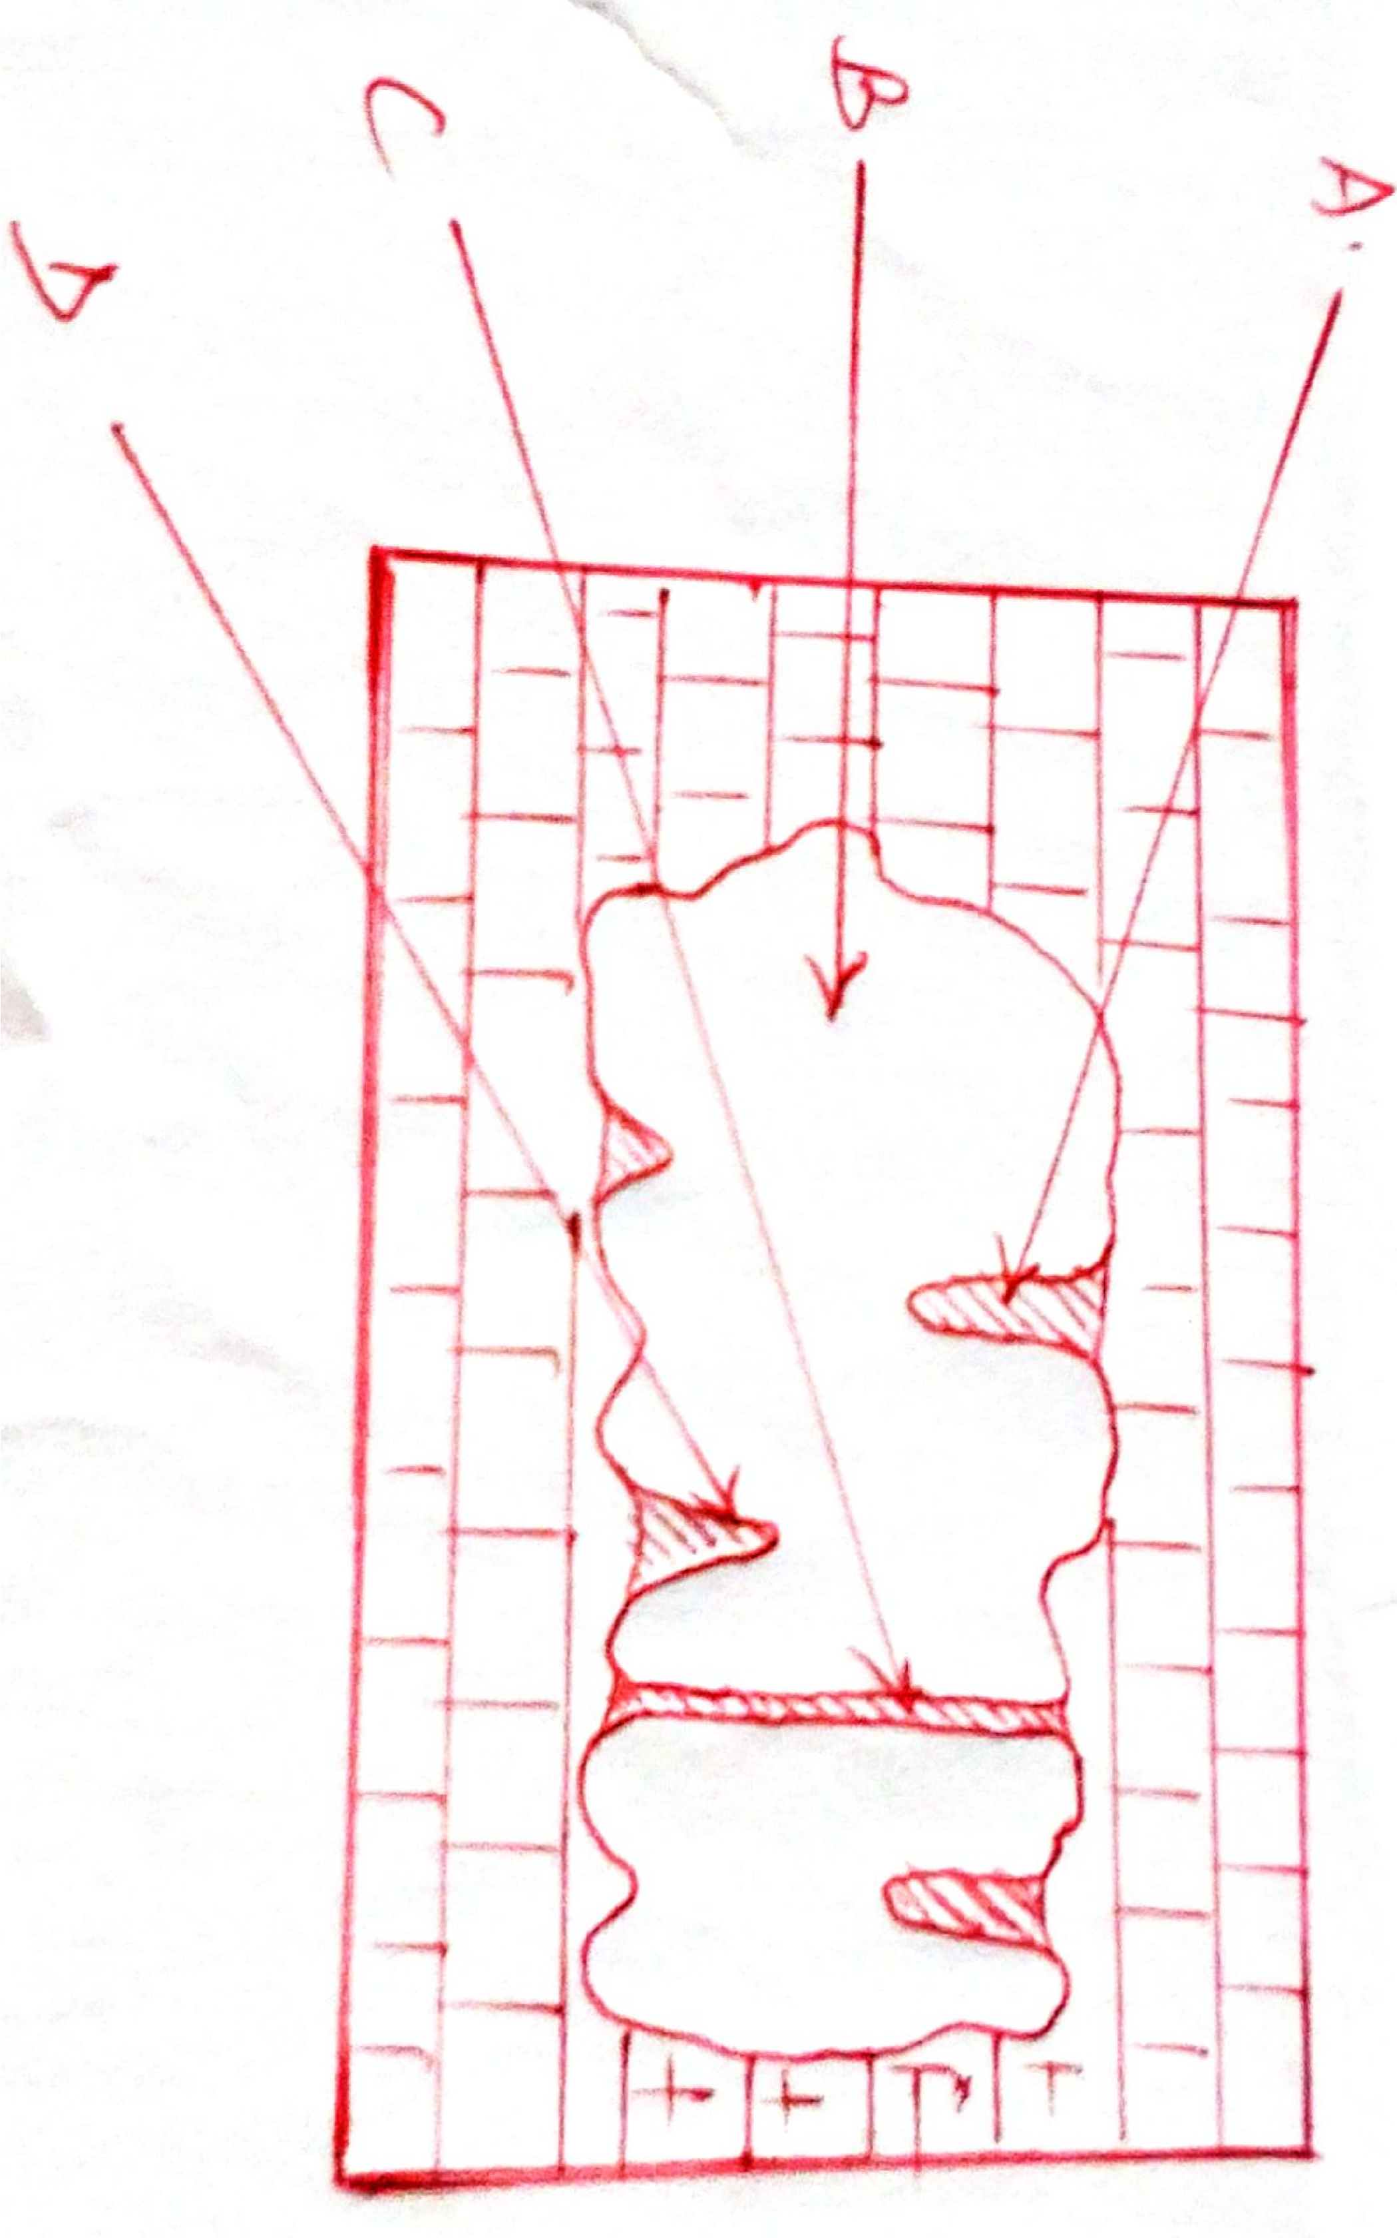
(c ) Name THREE features found on the surface of limestone areas. (3mks)

(d ) The diagram below shows some features formed in Karst regions. Use it to answer the questions that follow.

- Name the features marked A, B and C. (3mks)

- Describe how feature D is formed. (4mks)

( e) Students from Magina Girls school conducted field study in a limestone area.
- Give two reasons why it was necessary for them to carry out a reconnaissance. (2mks)

- Identify THREE economic uses of Karst landscape that they observed. (3mks)

- (a) Give THREE types of desert surfaces. (3mks)

(b) (i) State THREE reasons why wind action is effective in the desert regions. (3mks)

(ii) Describe the wind erosion processes in hot deserts (6mks)

(c ) (i) Apart from deflation hollows, name FOUR features formed by wind erosion in desert areas. (4mks)

(ii) Describe the formation of a deflation hollow. (4mks)

(d )(i) Distinguish between a playa and an alluvial fan. (2mks)

- Apart from playas and alluvial fans, name THREE other features formed by action of water in deserts. (3mks)

