END TERM EXAM
BIOLOGY PP2
FORM THREE.

NAME ……………………………………………… ADM …………………………

CLASS …………………………..
Answer all the questions in section A in the spaces provided.
In section B answer question 6 (Compulsory) and either question 7 or 8 in the spaces provided
after question 8.

SECTION A (40MARKS) (ANSWER ALL QUESTIONS)

1. The apparatus below was used to investigate certain process that occurs in plants:-
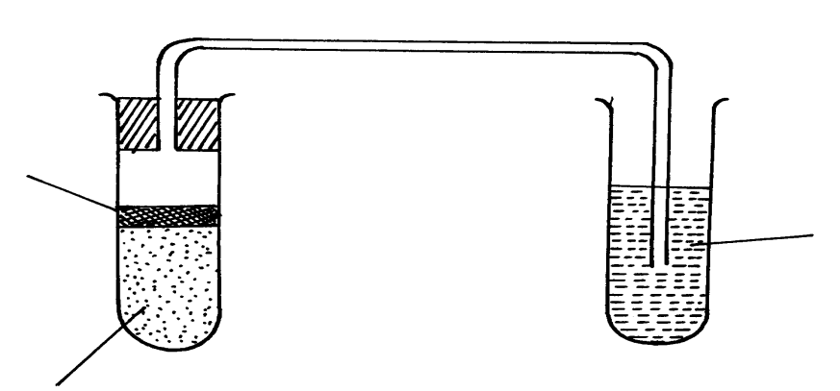
Oil film
Yeast + 10%
glucose solution
Lime water

(a)Name the process that was being investigated (1mk)

(b) How would you remove dissolved oxygen from the glucose before the experiment
commencing? (1mk)

(c) State what happens to the lime water as the experiment proceeds to the end (1mk)

(d) State the role of oil film the experiment (1mk)

(e) Explain what would happen if the temperature of glucose solution and yeast was raised beyond 45ºC? (1mk)

(f)State three economic importance of the process named in (a) above in industry? (3mks )

2. Two fresh potato cylinders of equal length were placed one in distilled water and the other in
concentrated sucrose solution:

(a)State the expected observations in term of length of the potato cylinders in (2mks)
(i)distilled water

(ii)sucrose solution

(b) Account for the change in length of the cylinder in:
(i) Distilled water (1mk)

(ii) Sucrose solution (1mk)

(c) (i) What would be the result in terms of length if a boiled potato was used? (1mk)

(ii) Explain your answer in(b)(i) Above (1mk)

(d) State two uses of the physiological process being demonstrated in the experiment(2m)

3. (a) Distinguish between the terms homodont and heterodont. (1mk)

(b) What is the function of carnasial teeth? (1mk)

(c) A certain animal has no incisors, no canines, 6 premolars and 6
molars in its upper jaw, in the lower jaw there are 6 incisors, 2 canines, 6 premolars and 6 molars. Write its dental formula (1mk)

(d) Suggest the likely type of food eaten yby the organism (1mk)

(e) The action of ptyalin stops at the stomach. Explain. (1mk)

(f) State a factor that denatures enzymes. (1mk)

(g) Name two features that increase the surface area of small intestines. (2mks)

4 . (a) Describe how insect pollinated flowers are adopted to pollination ( 5 marks)

(b) Describe the role of each of the following hormones in the human menstrual
cycle. ( 3 marks)
- Oestrogen

- Progesterone

- Luteinizing hormone

5. (a) What is meant by the following terms?
(i) Protandry ( 1 mark)

(ii) Self- sterility ( 1 mark)

(b)The diagram below shows a stage during fertilization in plant

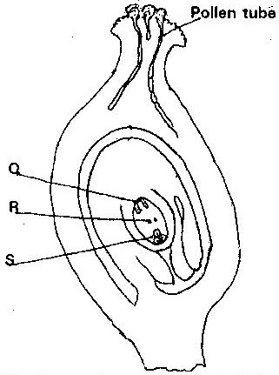

(i) Name the parts labeled Q, R, and S ( 3 marks)
Q
R
S
(ii) State two functions of the pollen tube ( 2 marks)

- On the diagram, label the micropyle ( 1 mark)

SECTION B (40 MARKS)
Answer question 6 (compulsory) in the spaces provided and either question 7 OR 8 in the spaces provided after question 8.
6. In an ecological study, a locust population and that of crows was estimated in a grassland area over a period of one year. The results were tabulated as shown below.

Months | J | F | M | A | M | J | A | S | O | N | D
No. of Adult locusts x 10² | 90 | 20 | 11 | 25 | 200 | 652 | 15 | 10 | 35 | 192 | 456
Number of crows | 4 | 2 | 0 | 1 | 8 | 22 | 2 | 1 | 1 | 5 | 15
Amount of rainfall | 20 | 0 | 55 | 350 | 520 | 350 | 10 | 25 | 190 | 256 | 350

a) Draw a graph of population of locusts and crows against time (7mks)
b) i) State the relationship between rainfall and locust population (1mk)

ii) Account for the relationship you have stated in b (i) above (2mks)

c) What happens on the populations of locusts and crows in the months of January to March? Give a reason. (2mks)

d) If the area of study was one square kilometer, state one method used to estimate the
population of :- (2mks)
- Locusts

- Crows

(e) (i) State the trophic levels of the (2mks)
(i) Locusts

(ii) crows

(ii) Construct a simple complete food chain involving these organisms (1mk)

(f) If the locust were removed from the food chain, what would be its effect? (2mks)

(g) Define biomass (1mk)

7. Describe the
(a) Process of inhalation in mammals. (10 mks)
(b) Mechanism of opening and closing of stomata (10 mks)
8. Describe how fruits and seeds are suited to their mode of dispersal (20mks)

