**NAME ............................................................................CLASS.....................ADM ……….....…**

**END TERM 2 EXAMS 2021**

**443/1**

**AGRICULTURE**

**PAPER 1**

**TIME: 2 HOURS**

**FORM 3**

**Instructions**

* Write your name , class, admission number above
* This paper consist of three section A, B, and C
* Answer all questions in section A and B
* Answer any two questions in section C
* All answers should be written in the spaces provided

FOR EXAMINERS USE ONLY

|  |  |  |  |
| --- | --- | --- | --- |
| SECTION | QUESTION | MAXIMUM SCORE | CANDIDATE SCORE |
| A | 1-16 | 30 |  |
| B | 17-20 | 20 |  |
| C |  | 20 |  |
|  |  | 20 |  |
|  | TOTAL SCORE | 90 |  |

**SECTION A (30 MARKS**

**Answer all question in this section in the space provided**

1. Differentiate between **olericulture** and **pomoculture** as used in crop production (1mk)
2. List the physical weathering agents in soil formation process (1 ½ mks)
3. Give four advantages of crop rotation. (2mk)
4. Give two conditions where opportunity cost does not exist (2mrks)
5. State four advantages of drip irrigation. (2mks)

6 Give four benefits of adding organic manure to sandy soil. (2mks)

1. State two forms in which water is available in the soil. (1mk)
2. Give four advantages of using seeds over vegetative materials. (2 mks)

9. Give four benefits of possessing a land title deed (2mks)

1. Give three reasons why primary cultivation should be done early before the onset of the rains (1 ½mks )
2. State four features of crops selected in preparation of green manure (2mks)

 11. Name any four methods of farming in Agriculture (2mks)

12. Highlight any four postharvest practices undertaken in cereal crops (2mks)

13. Horticultural production can be carried out in several ways name them. (11/2 mks)

14. What name is given to the practice of removing of suckers from coffee bushes (1/2 mk)

15. State six ways in which soil may lose its fertility. (3 mks)

16. Name four categories of vegetables and give an example in each case (2mks)

**SECTION B (20 MARKS)**

**Answer all the questions in this section in the spaces provided**

17. Given that a maize crop is planted at a spacing of 75cm x 25cm, calculate the plant population in one hectare of land if two seeds are planted per hole. (Show your working). (3mks)

18. The diagram below shows a method of crop propagation .Study it and answer the questions that follow

* + 1. 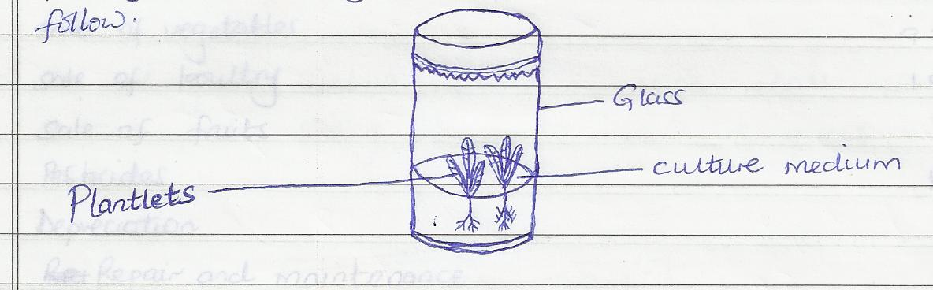

a) Identify the method (1mk)

1. Name two crops that can be propagated using this method. ( 2mks)
2. Give two ingredients used when preparing tissue culture. (2mks)

d) State three advantages of the method above (3mks)

19. The diagram below show a set of an experiment to study an aspect of soil. The set up was left undisturbed for twenty four hours (24hrs). Study it and answer the questions that follow.

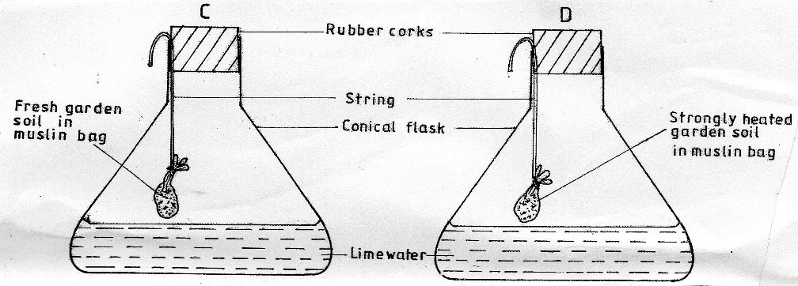

1. What was the aim of the experiment? (1mk)

1. State one observation that was made in each conical flasks labeled C and D. (2mks)
2. Give a reason for each of your answers in (b) above. (2mks)

C -

D-

20. Study the illustration below and answer questions that follow.



(i) Identify the weed. (1mk)

(ii) Give two harmful effects of the weed illustrated above. (2mks)

(iii) State one reason why tillage is sometimes preferred as a method of weed control. (1mk)

**SECTION C (40MARKS)**

**Answer any two questions in this section in the spaces provided**

21. a) Explain eight ways in which soil fertility can be maintained (8mks)

b) Describe the transplanting of tomato seedlings. (12mks)

22 a) Discuss six reasons for pruning coffee (6mks)

b) Describe the factors considered when siting a vegetable nursery bed (6mks)

c) Explain four factors that determine the spacing to be used in crops (8mks)

23. a) Describe five methods of preventing water pollution (5mks) b) Describe the process of water treatment. (10mks)

c) Explain five roles of Agriculture in the economy (5mks)