**NAME­­­­­­­­­­­‑‑‑‑‑‑‑‑‑‑‑‑‑‑‑‑‑‑‑‑‑‑‑‑‑‑‑‑‑‑‑‑‑‑‑‑‑‑‑‑‑‑‑‑‑‑‑‑‑‑‑‑‑‑‑‑‑‑‑‑‑‑‑‑‑‑‑‑ADM NO‑‑‑‑‑‑‑‑‑‑‑‑‑‑CLASS‑‑‑‑‑‑‑‑‑‑**

**END TERM 2 EXAM 2021**

**AGRICULTURE**

**FORM 2**

**TIME: 2 HOURS**

**Instructions: *Answer ALL the questions in the spaces provided***

1. Differentiate between: (2mks)
2. Arable and mixed farming
3. Apiculture and aquaculture
4. Name three biotic factors that affect agriculture negatively (1 ½ mks)
5. State two farming activities that may cause water pollution in the farm (1mk)
6. Give four reasons why aslasher should be maintained properly (2mks)

1. Give two forms of soil water (1mk)
2. State three importance of keeping animals healthy (1 ½ mks)
3. Name three categories of vegetables (1 ½ mks)
4. State four pre-disposing factors of livestock diseases (2mks)
5. State three disease preventive measures carried out in livestock (1 ½ mks)
6. State four mechanical methods of controlling ticks (2mks)
7. Give the two dual purpose breeds of sheep (1mk)
8. State two causes of blossom-end rot (2mks)

1. Give two surface water sources for use in a farm (1 mks)
2. Name two macronutrients which are classified as:
3. Liming element (1mk)
4. Fertilizer elements (1mk)
5. What do you understand by the term micro-nutrients as used in crop production (1mk)
6. Name the routine field practice done by:
7. Removal of extra suckers in a banana stool (1/2mk)
8. Removal of old stem down to the level of top foliage in pyrethrum (1/2mk)
9. Removal of suckers from coffee bushes (1/2mk)
10. Removal and destruction of infected plants and plant parts (1/2mk)
11. List any four ways in which soil is deprived of its fertility (2mks)
12. Give four benefits of crop rotation (2mks)
13. Name two plant parts used for propagation of pineapples (1mk)
14. The diagram below illustrates a method of crop propagation

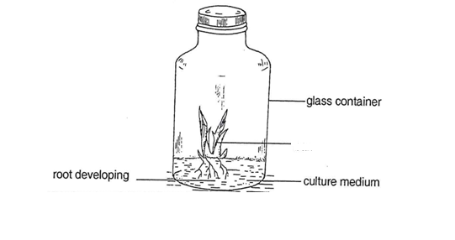

1. Identify the method of propagation (1mk)
2. Name one crop propagated through the method (1mk)
3. State three importance of the method above (3mks)
4. Below is a diagram that illustrates a practice in raising tea seedlings. Study it and answer the questions that follow.

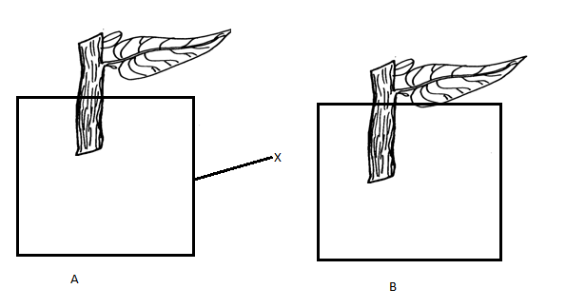

1. Identify the diagram that shows the right way to place the stem cutting (1mk)
2. Name the part labeled X on the diagram above (1mk)
3. List the composition of the materials that is inside X (3mks)
4. The diagram below represents a type of irrigation

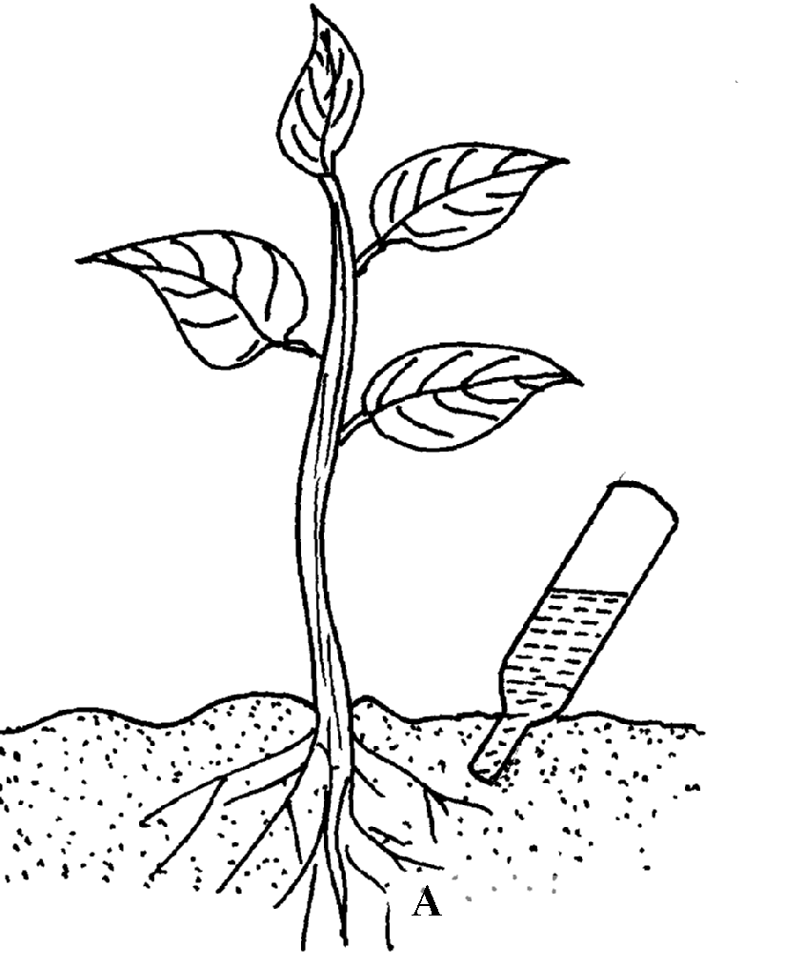

1. Identify the type of irrigation (1mk)
2. State four advantages of the irrigation named above (4mks)
3. The diagram below represents a pest that attacks tomatoes.



1. Identify the pest. (1mk)

b. State appropriate control measure of the above pest. (1mk)

c. Name **thre**e diseases that attacks the crop above (3mks)

1. a) State four factors that determine the quality of farmyard manure (4 mks)

b) State three reasons why green manure is not commonly used in Kenya (3mks)

1. Explain five nursery management practices (10mks)
2. Name three types of water pumps as used in the farm (3mks)