NAME………………………………………………………..ADM.NO…………..CLASS……
FORM ONE GEOGRAPHY
END OF TERM 2 2021 EXAM
DURATION: 1 HR 45 MINUTES
INSTRUCTIONS: Answer all the questions in the spaces provided.
1. (a) Define the term environment. (2 marks)
………………………………………………………………………………………………………………………………………………………………………………………………………………………………………………………………………………………………………………………………………………………………………………………………………………………………………………………………
(b) Name the two types of environment. (2 marks)
………………………………………………………………………………………………………………………………………………………………………………………………………………………………………………………………………………………………………………………………………………………………………………………………………………………………………………………………
(c) Give four areas studied under physical Geography. (4 marks)
…………………………………………………………………………………………………………………………………………………………………………………………………………………………………………………………………………………………………………………………………………………………………………………………………………………………………………………………………………………………………………………………………………………………………………………………………………………………………………………………………………………………………………………………………………………………………………
2. (a) Define the term solar system. (2 marks)
………………………………………………………………………………………………………………………………………………………………………………………………………………………………………………………………………………………………………………………………………………………………………………………………………………………………………………………………
(b) State three characteristics of planet mercury. (3 marks)
……………………………………………………………………………………………………………………………………………………………………………………………………………………………………………………………………………………………………………………………………………………………………………………………………………………………………………………………………………………………………………………………………………………………………………………………………………………

3. The diagram below represents the earth on its axis.
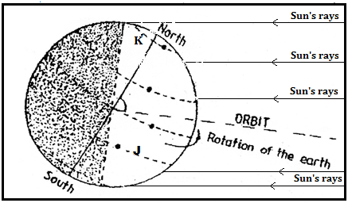
(a) (i) Name the latitudes marked J and K. (2 marks)
………………………………………………………………………………………………………………………………………………………………………………………………………………………………………………………………………………………………………………………………………………………………………………………………………………………………………………………………
(ii) According to the diagram, which season is being experienced at:
-Northern hemisphere (1 mark)
…………………………………………………………………………………………………………………………………………………………………………………………………………………………………………………………………………………………………………
-Southern hemisphere (1 mark)
…………………………………………………………………………………………………………………………………………………………………………………………………………………………………………………………………………………………………………
(b) State four effects of the movement of the earth on its own axis (4 marks)
…………………………………………………………………………………………………………………………………………………………………………………………………………………………………………………………………………………………………………………………………………………………………………………………………………………………………………………………………………………………………………………………………………………………………………………………………………………………………………………………………………………………………………………………………………………………………………
(c) State four characteristics of the earth’s core. (4 marks)
……………………………………………………………………………………………………………………………………………………………………………………………………………………………………………………………………………………………………………………………………………………………………………………………………………………………………………………………………………………………………………………………………………………………………………………………………………………………………………………………………………………………………………………………………………………………………………………………………………………………………………………………………………………………………………………………………………………………………………………………………………………………………………………………………………………
4. (a) Define the term weather. (2 marks)
………………………………………………………………………………………………………………………………………………………………………………………………………………………………………………………………………………………………………………………………………………………………………………………………………………………………………………………………
(b) List four factors that affect the humidity of a place. (4 marks)
…………………………………………………………………………………………………………………………………………………………………………………………………………………………………………………………………………………………………………………………………………………………………………………………………………………………………………………………………………………………………………………………………………………………………………………………………………………………………………………………………………………………………………………………………………………………………………
5. The diagram below represents some types of clouds
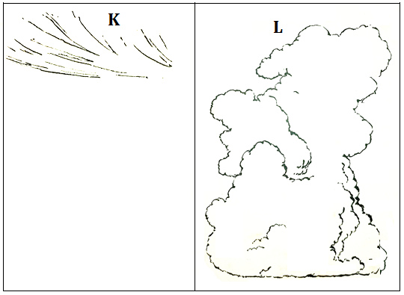
(a) Identify the clouds marked K and L. (2 marks)
………………………………………………………………………………………………………………………………………………………………………………………………………………………………………………………………………………………………………………………………………………………………………………………………………………………………………………………………
(b) Give three weather conditions associated with the cloud marked L. (3 marks)
…………………………………………………………………………………………………………………………………………………………………………………………………………………………………………………………………………………………………………………………………………………………………………………………………………………………………………………………………………………………………………………………………………………………………………………………………………………………………………………………………………………………………………………………………………………………………………
6. With the aid of a labelled diagram, describe how relief rainfall is formed. (7 marks)
……………………………………………………………………………………………………………………………………………………………………………………………………………………………………………………………………………………………………………………………………………………………………………………………………………………………………………………………………………………………………………………………………………………………………………………………………………………………………………………………………………………………………………………………………………………………………………………………………………………………………………………………………………………………………………………………………………………………………………………………………………………………………………………………………………………………………………………………………………………………………………………………………………………………………………………………………………………………………………………………………………………………………………………………………………………………………………………………………………………………………………………………………………………………………………………………………………………………………………………………………………………………………………………………………………………………………………………………………………………………………………………………………………………………………………………………………………………………………………………………………………………………………………………………………………………………………………………………………………………………………………………………………………………………………………………………………………………………………………………………………………………………………………………………………………………………………………………………………………………………………………………………………………………………………………………………………………………………………………………………………………………………………………………………………………………………………………………………………………………………………………………………………………………………………………………………………………………………………………………………………………………………………………………………………………………………………………………………………………………………………………………………………………………………………………………………………………………………………………………………………………………………………………………………………………………………………………………………………………………………………………………………………………………………………………………………………………………………………………………………………………………………………………………………………………………………………………………………………………………………………………………………………………………

7. Suppose you were to carry out a field study on a weather station in your County:
(a) State four ways in which you would prepare for the study. (4 marks)
…………………………………………………………………………………………………………………………………………………………………………………………………………………………………………………………………………………………………………………………………………………………………………………………………………………………………………………………………………………………………………………………………………………………………………………………………………………………………………………………………………………………………………………………………………………………………………
(b) Give three methods that you would use to record data. (3 marks)
……………………………………………………………………………………………………………………………………………………………………………………………………………………………………………………………………………………………………………………………………………………………………………………………………………………………………………………………………………………………………………………………………………………………………………………………………………………
(c) State four follow up activities that you would carry out after the study. (4 marks)
…………………………………………………………………………………………………………………………………………………………………………………………………………………………………………………………………………………………………………………………………………………………………………………………………………………………………………………………………………………………………………………………………………………………………………………………………………………………………………………………………………………………………………………………………………………………………………
8. (a) Differentiate between a map and a plan. (2 marks)
……………………………………………………………………………………………………………………………………………………………………………………………………………………………………………………………………………………………………………………………………………………………………………………………………………………………………………………………………………………………………………………………………………………………………………………………………………………
(b) With reference to map work, list three types of scale. (3 marks)
…………………………………………………………………………………………………………………………………………………………………………………………………………………………………………………………………………………………………………………………………………………………………………………………………………………………………………………………………………………………………………………………………………………………………………………………………………………………………………………………………………………………………………………………………………………………………………
9. The table below represents rainfall and temperature for City K in 2012. Use it to answer question (a) and (b).

Months | J | F | M | A | M | J | J | A | S | O | N | D
Temp ^{O}C | 27 | 25 | 30 | 25 | 20 | 18 | 17 | 24 | 27 | 28 | 27 | 28
Rainfall (mm) | 100 | 250 | 350 | 425 | 400 | 200 | 50 | 50 | 100 | 325 | 400 | 300

(a) (i) Calculate the mean annual temperature for City K. (2 marks)
…………………………………………………………………………………………………………………………………………………………………………………………………………………………………………………………………………………………………………………………………………………………………………………………………………………………………………………………………………………………………………………………………………………………………………………………………………………………………………………………………………………………………………………………………………………………………………

(ii) Calculate the annual rainfall total for City K. (2 marks)
…………………………………………………………………………………………………………………………………………………………………………………………………………………………………………………………………………………………………………………………………………………………………………………………………………………………………………………………………………………………………………………………………………………………………………………………………………………………………………………………………………………………………………………………………………………………………………

(iii) What is the annual range of temperature for City K? (1 mark)
……………………………………………………………………………………………………………………………………………………………………………………………………………………………………………………………………………………………………………………………………………………………………………………………………………………………………………………………………………………………………………………………………………………………………………………………………………………
(b) Using a vertical scale of 1cm to represent 50mm, draw a simple bar graph to represent rainfall data for City K in 2012. Use the graph paper provided. (6 marks)

