NAME:……………………………………………………..ADM:…………..CLASS:…………..

BIOLOGY
FORM 1
END TERM 2, 2021
TIME:
- (a) Define the following terms. (3mks)
- Respiration

- Excretion

- Irrilability

(b) State the importance of the following processes to an organism. (2mks)
(i) Excretion

(ii) Irritability

- (a) Define the following terms. (4mks)
- Classification

- Taxonomy

- Binomial nomenclature

- Taxon

- (a) Name two instruments used in the laboratory for magnification. (2mks)

(b) A student drew a cross section of a tomato fruit whose magnification was x6. The diameter of the tomato was 4cm. What was the diameter of the drawing? (3mks)

- Which tissues perform the following functions in plants? (4mks)
- Synthesis of food

- Cell division to make new tissues

- Protecting inner delicate tissues

- Fill in spaces between other tissues

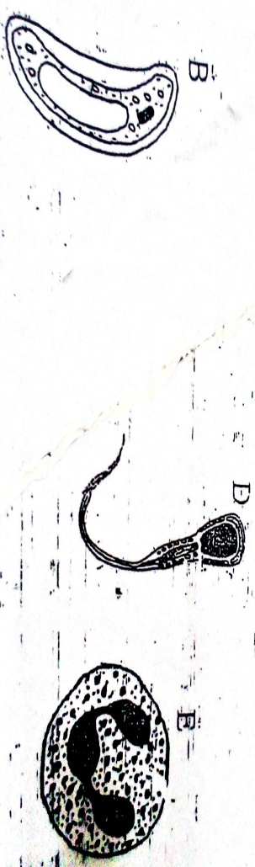
- Below are three different cells B, D and E. (3mks)

- Identify each of the cells
(B)

(D)

(E)

- State the function of cell B. (1mk)

- Outline three differences between a light and electron microscope. (3mks)

- Define the following terms.
- Diffusion (1mk)

- Active transport (2mks)

- Osmosis (1mk)

- Which physiological process would be involved in the following? (4mks)
- Absorption of mineral irons by plant roots from the soil.

- Absorption of water from soil by plant roots.

- Reabsorption of
- Glucose in the Kidney tubules

- Water along Kidney tubules

- An experiment was set up as shown below. Use it to answer the question that follow.

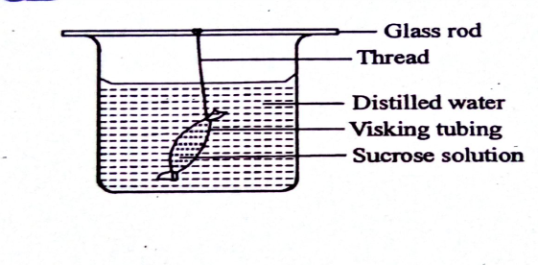

- Identify the process being investigated

- State the expected results after 40 minutes. (1 mk)

- Explain the answer in (b) above. (2mks)

- (a) Define the term nutrition. (1mk)

(b) Differentiate between
(i) Autotrophism and Heterotrophism (2mks)

(ii) Photosynthesis and Chemosynthesis (2mks)

(c )Identify any three cells in a leaf which are photosynthetic (3mks)

( d) Identify the cell structure that the cells named above have in common to perform photosynthesis. (1mk)

(e ) Give the reason why cuticle and epidermal cells of a leaf are transparent (1mks)

- (a) State two factors which affect the rate of photosynthesis (2mks)

(b) State the site where the following stages of photosynthesis take place (2mks)
(i) Light stage

(ii )Dark stage

- (a) State the name given to study of chemicals of life and the reactions they take part.

(b) Name the building blocks (simplest forms) of the following chemicals of life
(i) Carbohydrates (1mk)

(ii) Lipids (1mk)

- Protein (1mk)

(c ) State two properties of proteins. (2mks)

- Outline three functions of lipids. (3mks)

- State two roles of enzymes in the body (2mks)

- Below is a diagram showing the longitudinal section of a tooth.
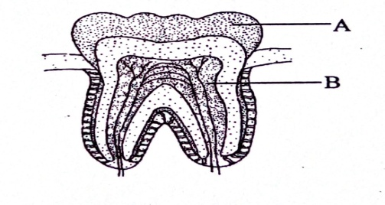

- Identify the tooth. (1mk)

- Give a reason for your answer in (a) above. (1mk)

- Identify the parts A and B. (2mks)

- Name two structure found in part B. (2mks)

- (a) Define the term digestion as used in heterotrophic nutrition. (1mk)

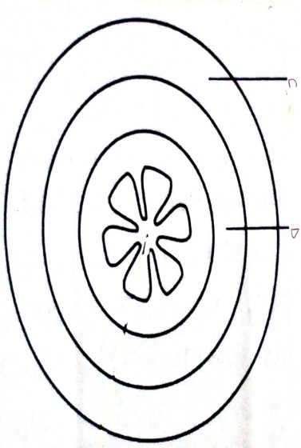
(b) The diagram below shows a transverse section of gut wall of mammals.

(i) Name the muscles C and D. (2mks)

(ii) State the importance of these muscle. (1mk)

