Name: …………………………………………………………… …………Adm. No.……..….........................

Date: …………………………………………………………… Class: ………......…………….

565/1
FORM 3 BUSINESS STUDIES
PAPER 1
NOV/DEC 2021
TIME: 2 HOURS

Kenya Certificate of Secondary Education (K.C.S.E.)

FORM 3 BUSINESS STUDIES
PAPER 1
TIME: 2 HOURS

INSTRUCTIONS TO CANDIDATES:

- Write your name and your Admission Number in the spaces provided above.
- Write the date of examination and class in the spaces provided above.
- Answer all the questions in the spaces provided.
- All answers should be written in English.
- This paper consists of 9 printed pages. Candidates should check the question paper to ascertain that all the pages are printed as indicated and that no questions are missing.

FOR EXAMINERS USE ONLY:-
Question | 1 | 2 | 3 | 4 | 5 | 6 | 7 | 8 | 9 | 10 | 11 | 12 | 13
Score

Question | 14 | 15 | 16 | 17 | 18 | 19 | 20 | 21 | 22 | 23 | 24 | 25
Score

TOTAL MARKS

- State 4 reasons that would make an individual engage in business (4marks)

(i) …………………………………………………….…………………………………………………….
(ii) ……………………………………………….……………………………….…………………………
(iii) …………………………………………………………………………………………………………..
(iv) ………………………………………………………………………………………………………….
- State whether the following factors will affect the business environment internally or externally (4marks)
Factor Effect

- Competition ……………………………………..
- Terrorism threat ……………………………………..
- Human resource management ……………………………………..
- Production capacity ……………………………………..

- Outline 4 characteristics of economic resources (4marks)
(i) …………………………………………………….…………………………………………………….
(ii) ……………………………………………….……………………………….…………………………
(iii) …………………………………………………………………………………………………………..
(iv) ………………………………………………………………………………………………………….
- Outline types of utility and the production activity associated with each of them (4marks)
Utility Production activity
- …………………………. ……………………………………………
- …………………………. ……………………………………………
- …………………………. ……………………………………………
- …………………………. ……………………………………………

- Highlight four ways in which the office facilitates effective handling of documents (4mks)

(i) …………………………………………………….…………………………………………………….
(ii) ……………………………………………….……………………………….…………………………
(iii) …………………………………………………………………………………………………………..
(iv) ………………………………………………………………………………………………………….

- Outline 4 disadvantages of using automatic vending machine (4marks)

- ………………………………………….…………………………………………………
- ………………………………………….……………………………….………………………
- …………………………………………………………………………………………………
- …………………………………………………………………………………………………
- Outline 4 types of wholesalers (4marks)

(i) …………………………………………………….…………………………………………………….
(ii) ……………………………………………….……………………………….…………………………
(iii) …………………………………………………………………………………………………………..
(iv) ………………………………………………………………………………………………………….
- State four reasons why there is increased use of mobile phones in banking (4marks)

(i) …………………………………………………….…………………………………………………….
(ii) ……………………………………………….……………………………….…………………………
(iii) …………………………………………………………………………………………………………..
(iv) ………………………………………………………………………………………………………….
- State 4 reasons why a consumer may prefer buying goods from a supermarket to a small scale retail shop (4marks)

(i) …………………………………………………….…………………………………………………….
(ii) ……………………………………………….……………………………….…………………………
(iii) …………………………………………………………………………………………………………..
(iv) ………………………………………………………………………………………………………….
- State 4 factors that a retailer would consider before allowing a customer to buy goods on credit
(4marks)
(i) …………………………………………………….…………………………………………………….
(ii) ……………………………………………….……………………………….…………………………
(iii) …………………………………………………………………………………………………………..
(iv) ………………………………………………………………………………………………………….
- State 4 documents that should be submitted to the registrar of companies for the purpose of registering a limited liability company (4marks)
- …………………………………………………….…………………………………………………….
(ii) ……………………………………………….……………………………….…………………………
(iii) …………………………………………………………………………………………………………..
(iv) ………………………………………………………………………………………………………….
- Highlight 4 ways in which the government of Kenya may regulate her business activities (4marks)

- …………………………………………………….…………………………………………………….
(ii) ……………………………………………….……………………………….…………………………
(iii) …………………………………………………………………………………………………………..
(iv) ………………………………………………………………………………………………………….

- Outline 4 features of an efficient transport system (4marks)
- …………………………………………………….…………………………………………………….
- ……………………………………………….……………………………….……………………..
- ………………………………………………………………………………………………………
- ……………………………………………………………………………………………………

- Highlight 4 factors that may render communication ineffective (4mks)
- …………………………………………………….…………………………………………………….
- …….……………………………………………….……………………………….……………..
- ………………………………………………………………………………………………………
- ……………………………………………………………………………………………………

- The table below contains descriptions relating to some types of warehouse. In the spaces provided, write the type of warehouse to which each description refers (4marks)
Description | Type of warehouse
- Used to store exports & imports
- Operated for the owner’s exclusive use
- Owned and operated by manufacturers and farmers
- Anybody can rent space in it for storing goods temporarily

- Outline 4 factors that may render communication ineffective (4marks)

(i) …………………………………………………….…………………………………………………….
(ii) ……………………………………………….……………………………….…………………………
(iii) …………………………………………………………………………………………………………..
(iv) ………………………………………………………………………………………………………….
- State the appropriate insurance policy your school can take to cover each of the following risks
Risks | Policy
- Losses arising from debtors failing to pay
- Injury caused to neighbour’s health due to school’s leaked sewer
- Loss of cash being delivered to the local bank
- To cover cooks from injuries that may occur to them in the kitchen
- Loss of money due to account’s clerk dishonesty
(5marks)

- Outline 4 qualities of a good salesperson (4marks)
(i) …………………………………………………….…………………………………………………….
(ii) ……………………………………………….……………………………….…………………………
(iii) …………………………………………………………………………………………………………..
(iv) ………………………………………………………………………………………………………….
- State 4 ways that a trader may provide after sale service to his customers (4marks)
(i) …………………………………………………….…………………………………………………….
(ii) ……………………………………………….……………………………….…………………………
(iii) …………………………………………………………………………………………………………..
- ………………………………………………………………………………………………………….

- State 3 circumstances under which a trader would advertise his products over the radio instead of television (3marks)
(i) …………………………………………………….…………………………………………………….
(ii) ……………………………………………….……………………………….…………………………
(iii) …………………………………………………………………………………………………………..

- The diagram below shows the demand and supply curves of a certain commodity and the corresponding equilibrium price (Pe) and quantity (Qe). On the diagram, show the new equilibrium quantity and price as a result of a decrease in the supply of the commodity. Write down your observation (4marks)

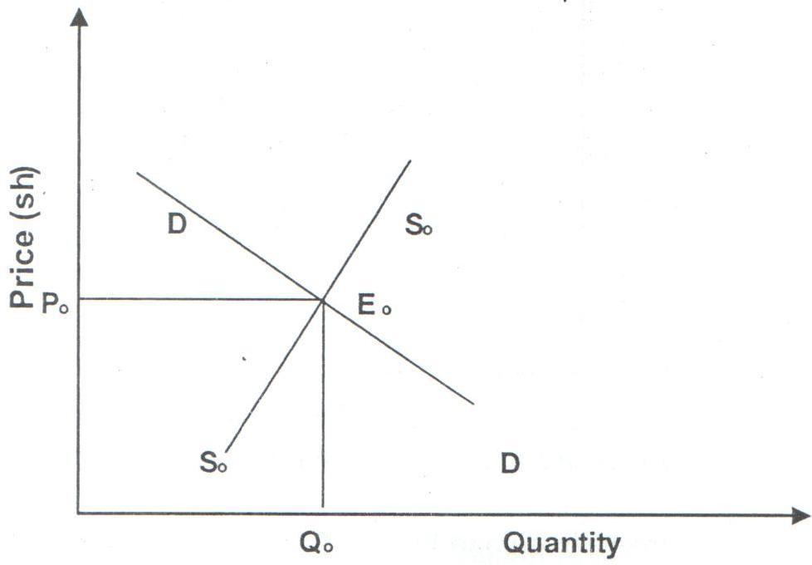

- Highlight 4 dangers of locating firms in a central place (4marks)

(i) …………………………………………………….…………………………………………………….
(ii) ……………………………………………….……………………………….…………………………
(iii) …………………………………………………………………………………………………………..
(iv) ………………………………………………………………………………………………………….

- Outline 4 characteristics of a perfect competition market structure (4marks)
- …………………………………………………….…………………………………………………….
(ii) ……………………………………………….……………………………….…………………………
(iii) …………………………………………………………………………………………………………..
(iv) ………………………………………………………………………………………………………….
- Outline 4 channels that can be used to distribute locally manufactured goods (4marks)

(i) …………………………………………………….…………………………………………………….
(ii) ……………………………………………….……………………………….…………………………
(iii) …………………………………………………………………………………………………………..
(iv) ………………………………………………………………………………………………………….

- Give 4 assumptions in a two sector economy circular flow of income (4marks)

(i) …………………………………………………….…………………………………………………….
(ii) ……………………………………………….……………………………….…………………………
- …………………………………………………………………………………………………………..
- …………………………………………………………………………………………………………..

