NAME…………………………………… INDEX NO. ………………………..……………

DATE…….……………………………… CANDIDATE'S SIGNATURE………………..
CLASS: ……………………………………………

312/2
GEOGRAPHY
PAPER2
DECEMBER, 2020
TIME: 2¾ HOURS

LANJET CLUSTER JOINT MOCK EXAMINATION
Kenya Certificate of Secondary Education
312/2
Paper 2
GEOGRAPHY
DECEMBER, 2020
TIME: 2 ¾ HOURS

INSTRUCTIONS
This paper has two sections: A &B.
- Answer all questions in section A.
- In section B, answer question 6 and any other two questions.
- Candidates should answer the questions in English.
- All answers to be written in foolscaps provided.

This paper consists of 6 printed pages. Candidates should check the question paper to ascertain that all pages are printed as indicated and that no pages are missing.

SECTION A
Answer all the questions in this section
1. (a) Give two uses of soda ash. (2mks)
(b) State three ways in which mining derelicts can be rehabilitated. (3mks)

2. (a) Name two exotic breeds of dairy cattle reared in Kenya. (2mks)
(b) State three physical factors that favour dairy farming in Denmark. (3mks)

3. (a) State two forms of Domestic trade. (2mks)
(b) State reasons countries institute measures to limit imports. (3mks)

4. (a) What is population structure. (2mks)
(b)Give the information that can be obtained from a population pyramid. (3mks)

5. Study the sketch map of Lake Victoria and use it to answer the question.

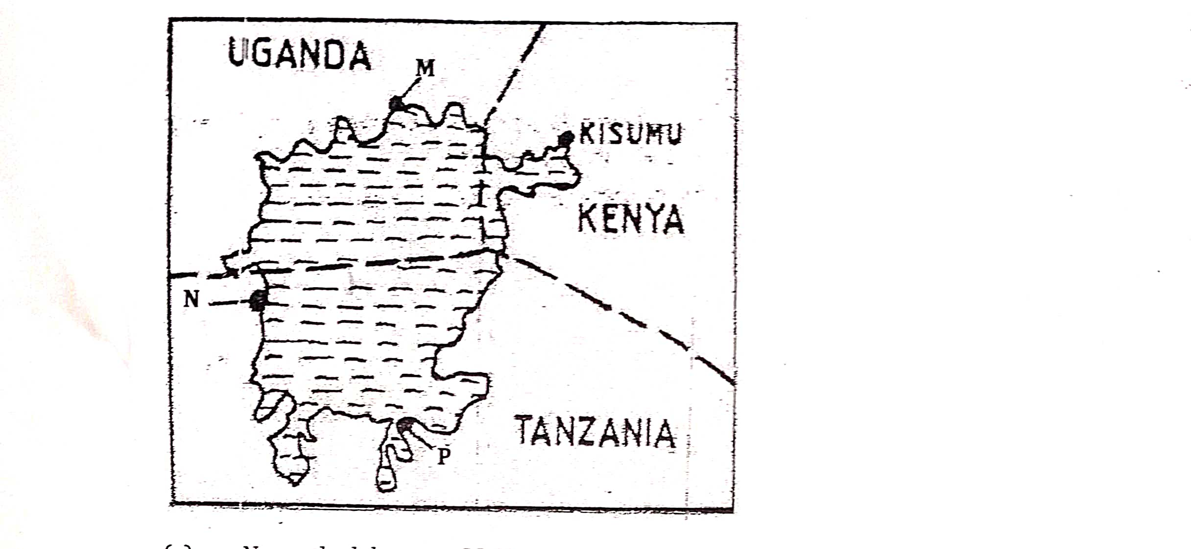
(a) Name the Lake Ports M,N and P.
(b) State three major sea routes in Africa. (3mks)

SECTION B
Answer question 6 and any other TWO questions from this section.
6. The table below shows Kenya’s export crops in the year 1998-2002 in ‘000’ tonnes. Study it and answer the questions that follows.
CROP | 1998 | 1999 | 2000 | 2001 | 2002
TEA | 420 | 510 | 580 | 420 | 490
HORTICULTURAL CROPS | 300 | 410 | 520 | 600 | 580
COFFEE | 270 | 360 | 480 | 500 | 420
TOTALS | 990 | 1280 | 1580 | 1520 | 1490
- (i) Use a suitable vertical and horizontal scale draw a compound bar graph to present this data. (9mks)
(ii) Give four physical conditions that favour coffee growing in Kenya. (4mks)
- Explain three problems facing coffee in Kenya. (6mks)
- Compare coffee growing in Kenya and Brazil under the following sub headings
(i) Coffee growing areas. (2mks)
(ii) Soils. (2mks)
(iii) Labour. (2mks)

7. (a) (i) What is agro forestry. (2mks)
(ii) Differentiate between indigenous and exotic forests . (2mks)
(iii) Name two indigenous soft wood tree species. (2mks)
(b) (i) Explain three factors that favour the growth of natural forest on the slopes of Mt.Kenya. (6mks)
(ii)State four factors that have led to the reduction of the area under forest on the slope of Mt. Kenya. (4mks)
- Give the difference in the exploitation of softwood forest in Kenya and Canada under the following headings.
(i)Tree species. (2mks)
(ii)Problems facing forestry. (2mks)
- Form Four students in your school carried out a field study on the forestry within their county.
- Give three reasons why reconnaissance was necessary for a field study. (3mks)
- State two advantages of content analysis in the study of a forests. (2mks)

8. (a)Differentiate between fishing and fisheries. (2mks)
(b)Name two types of marine fish caught along the east Africa coast. (2mks)
(c)Use the map of North-West Atlantic fishing ground to answer question

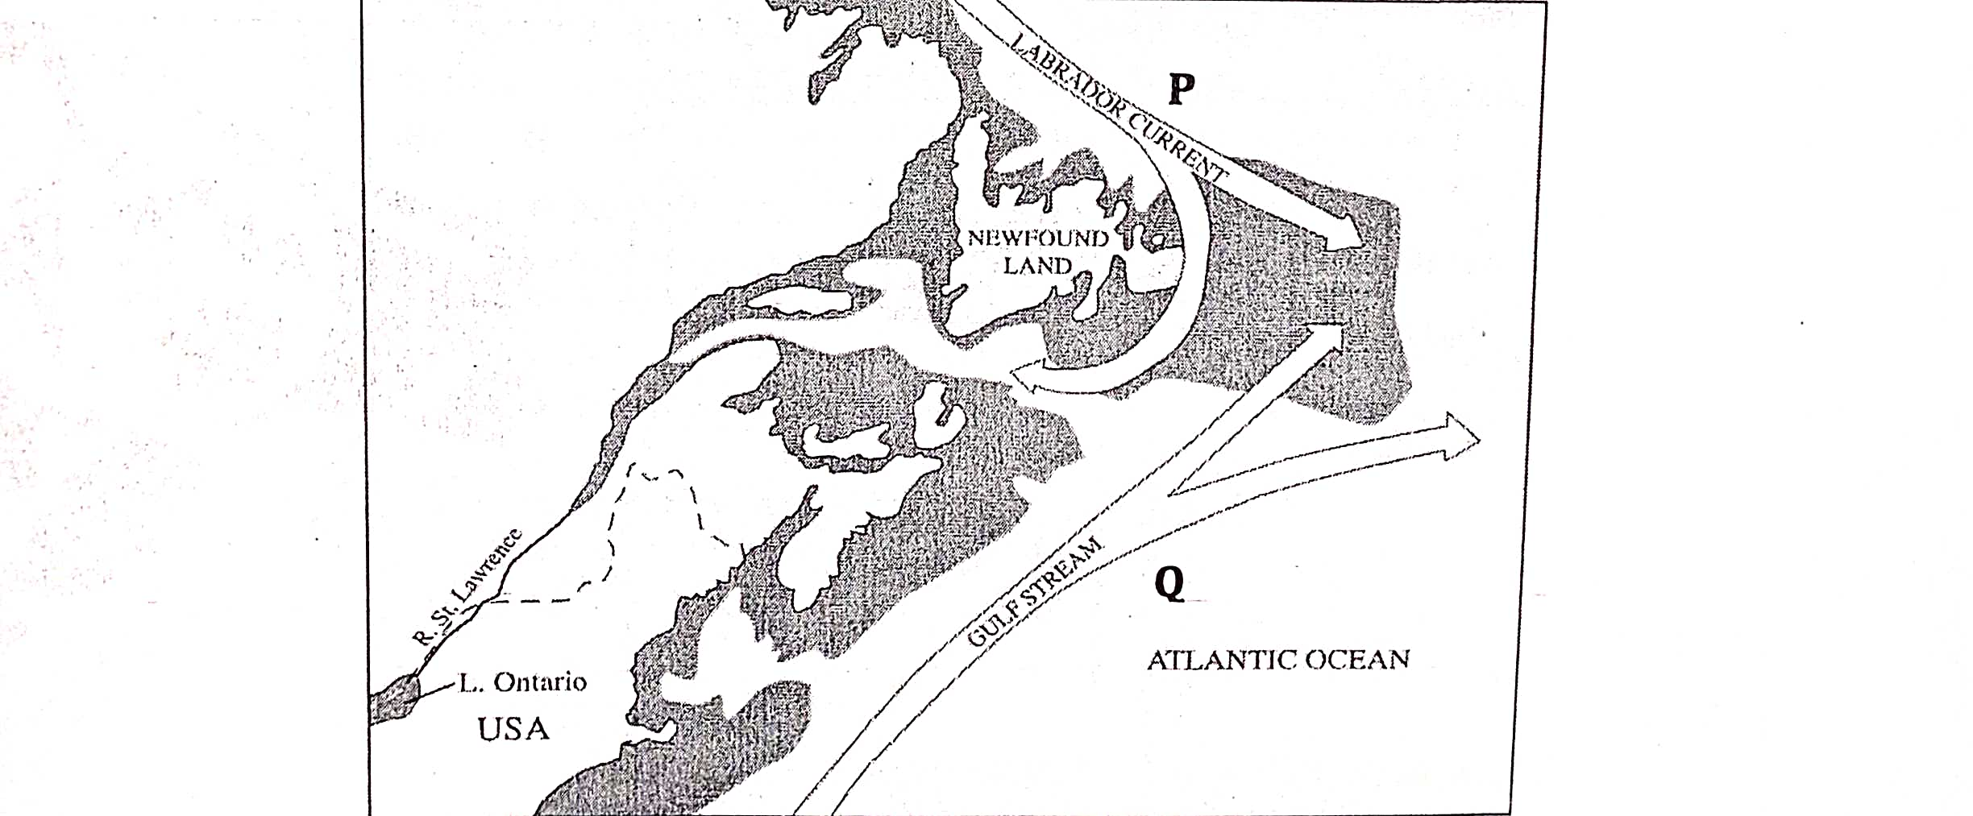

- Name the Ocean current marked P and Q. (2mks)
- Explain three ways in which the convergence of ocean currents marked P and Q influence fishing. (6mks)
(d) (i) Describe how drifting method is used in Fishing . (5mks)
(ii) State three factors which are considered when choosing a fishing method. (3mks)
(iii) State three problems which face fishing in Lake Turkana. (3mks)
- State two reasons why fish farming should be encouraged in Kenya . (2mks)
9. (a) (i) Give two non-renewable source of energy. (2mks)
(ii) State two advantages of using Uranium as a source of energy. (2mks)
(b) (i) Apart from generating H.E.P, give three other benefits that have resulted from the construction of Masinga dam. (3mks)
(ii) Explain four physical factors that influence the location of a hydro-electric power station. (8mks)
(c) (i) What is Energy crisis. (2mks)
(ii) Explain four effects that the increase in oil prices has had on the economy of Kenya. (8mks)
10. (a) (i) What is Environmental Hazards. (2mks)
(ii) Identify three types of environmental hazards. (3mks)
(b) (i) State three cause of floods. (3mks)
(ii)Explain four ways of combating floods in Kenya. (8mks)
(c)Students from your school carried out a field study on a flood prone area in your country.
(i) State five reasons why the working schedule as very important in their study. (5mks)
- What are the problems likely to be encountered during the field study. (4mks)

