NAME …………………………..……………….. DATE …………………………

INDEX NO. ……….……….…………………...…..… SIGNATURE ……………..…………..

231/3
BIOLOGY
PAPER 3
(PRACTICAL)
TIME: 1¾ HOURS.

LANET JOINT EVALUATION TEST, 2020
Kenya Certificate of Secondary Education

231/3
BIOLOGY
PAPER 3
(PRACTICAL)
NOVEMBER/DECEMBER 2020
TIME: 1¾ HOURS.

INSTRUCTIONS TO CANDIDATES
- Answer all the questions.
- You are required to spend the first 15 minutes of the 1¾ hours allowed for the paper reading the whole paper carefully before commencing your work.
- Answers must be written in the spaces provided in the question paper.
- Additional pages must not be inserted.
- This paper consists of 5 printed pages. Candidates should check to ensure that all pages are printed as indicated and no questions are missing

FOR EXAMINER’S USE ONLY
Questions | Maximum score | Candidate's score
Question 1 | 14
Question 2 | 14
Question 3 | 12
Total score | 40

- 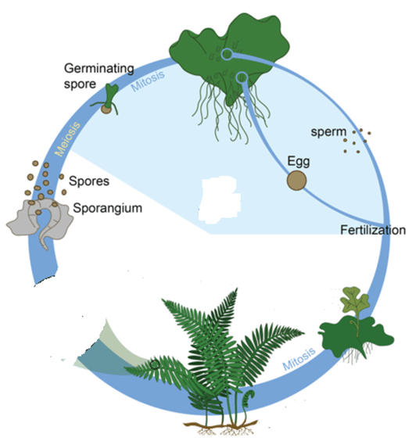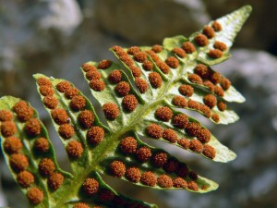The diagram below illustrates the life cycle of a certain organism.

Q
Z
B
A

K
- (i) Giving reasons, name the division to which the organism belongs.
Division………………………………………………………………………………(1mark)
Reasons (2marks)
…………………………………………………………………………………………………………
…………………………………………………………………………………………………………
…………………………………………………………………………………………………………

(ii) Which portion of the plant’s life is independent? (1mark)
………………………………………………………………................................................................................................................................................................…………………………………………
- (i) Name the parts labeled A and B. (2marks)

A …………………………...............................……………………………………………….

B …………………………................................………………………………………………

(ii) State one function of the part labeled B. (1mark)
…………………………………………………………………………………………………………
…………………………………………………………………………………………………………

(iii) Define the term alternation of generation. (1mark)
…………………………………………………………………………………………………………
…………………………………………………………………………………………………................................................................................................................................................................………
(ii) Identify the generations labeled K and L. (2marks)

Q …………………………………………………………………………….

Z ……………………………………………………………………………
(iii) In what way is generation L advantageous to generation K? (2marks)
…………………………………………………………………………………………………………
…………………………………………………………………………………………………………
…………………………………………………………………………………………………………
…………………………………………………………………………………………………………
(iv) Give a reason why the plant shown in the diagram above is common in swampy areas (2marks)
…………………………………………………………………………………………………………
…………………………………………………………………………………………………………

- You are provided with several specimens N and indicator D, which is Bromolthymol blue. Study them and answer the questions that follow:
- (i) Identify the part of plant represented by specimen N. (1mark)
…………………………………………………………………………………………………………
…………………………………………………………………………………………………………
(ii) Give a reason for your answer in a) i) above. (1mark)
.....…………………………………………………………………………………………………………
……………………………………………………………………………………….....…………………

- i) Name the physiological process which is taking place in specimen N. (1mark)
.....…………………………………………………………………………………………………………
……………………………………………………………………………………….....…………………
ii) Describe the two changes which occurred to specimen N during the process named in b) i) above. (2marks)
.....…………………………………………………………………………………………………………
……………………………………………………………………………………….....…………………
.....…………………………………………………………………………………………………………
……………………………………………………………………………………….....…………………
- i) State two internal factors which would promote the physiological process exhibited by specimen N, (2marks)
.....…………………………………………………………………………………………………………
……………………………………………………………………………………….....…………………
.....…………………………………………………………………………………………………………
ii) State two external conditions which would inhibit the process demonstrated by specimen N.(2marks)
.....…………………………………………………………………………………………………………
……………………………………………………………………………………….....…………………
.....…………………………………………………………………………………………………………

- Add 1ml of indicator marked D into a test tube, add 6 pieces of specimen N into the test tube. Close the mouth of the test tube tightly using a tissue paper. Leave the set up to stand on the tube rack for 30 minutes after which carefully remove specimen N without pouring the indicator marked D using a wooden splint.
- Record your observation after 30 minutes (1mark)
.....…………………………………………………………………………………………………………
……………………………………………………………………………………….....…………………
- Account the observation in d) i) above (3marks)
.....…………………………………………………………………………………………………………
……………………………………………………………………………………….....…………………
.....…………………………………………………………………………………………………………
……………………………………………………………………………………….....…………………
- Suggest a control for his experiment. (1mark)
.....…………………………………………………………………………………………………………
……………………………………………………………………………………….....…………………

- 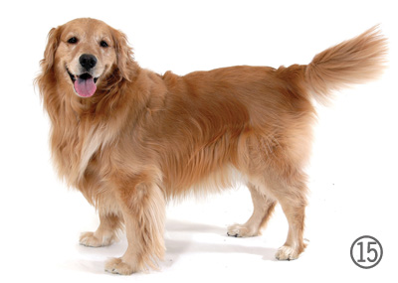You are provided with photograph L, K and J. Examine them.
PHOTOGRAPH L
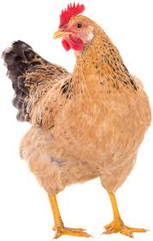
PHOTOGRAPH K

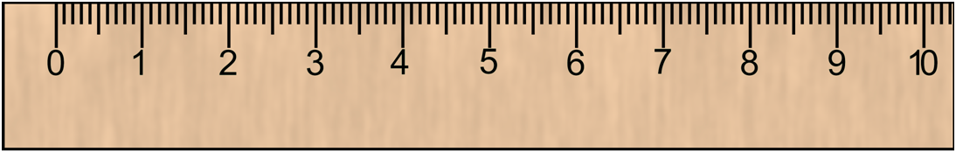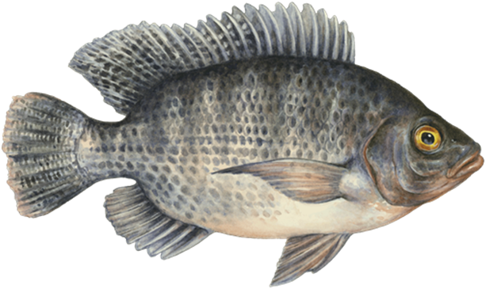
Anus
E
F
G
H
PHOTOGRAPH J
Anus
E
F
G
H
PHOTOGRAPH J
Anus
E
F
G
H
PHOTOGRAPH J

- Using observable features only, state class of animals shown in the photograph L and K. (4 marks)
L
Class ………………………………………………………………………………………………
Reason……………………………………………………………………………………………

K

Class ………………………………………………………………………………………………
Reason…………………………………………………………………………………………….

- (i) On the photograph J name the parts labeled E, F and G. (3 marks)
E..............………………………………………………………………………………………………
F..………………………………………………………………………………………………………
G.....……………………………………………………………………………………………………
(ii) State the functions of the structures labeled H in photograph J. (2marks)
..…………………………………………………………………………………………………………………………………………………………..………………………………………………………………………………………………………………..……………………………………………………

- (i) The actual length of animal J in cm is shown by a section of the ruler in the photograph.
Calculate the tail power (show your working) (2marks)

(ii) State the significance of tail power to the life of fish in water. (1mark)
…………………………………………………………………………………………………………
…………………………………………………………………………………………………………

