**NAME…………………………...……………………..… ADM NO…….………CLASS………**

**231/2**

**BIOLOGY**

**PAPER 2**

**(THEORY)**

**DECEMBER, 2020**

**TIME: 2 HOURS**

**LANET JOINT EXAMINATION**

***Kenya Certificate of Secondary Education (K.C.S.E)***

**INSTRUCTIONS TO CANDIDATES**

* Write your name and Index Number in the spaces provided above.
* This paper consists of **two** sections. Section **A** and section **B.**
* Answer **ALL** questions in section **A** in the spaces provided. In section **B** answer question **6** (compulsory) and either question **7** or **8** in the spaces provided after question 8
* This paper consists of 8 Printed pages. Candidates should check the question paper to ensure that all the papers are printed as indicated and no questions are missing.

**For Examiners use only.**

|  |  |  |  |
| --- | --- | --- | --- |
| **Section** | **Question** | **Maximum score** | **Candidates score** |
| **A** | **1** | **8** |  |
| **2** | **8** |  |
| **3** | **8** |  |
| **4** | **8** |  |
| **5** | **8** |  |
| **B** | **6** | **20** |  |
| **7** | **20** |  |
| **8** | **20** |  |
|  | **Total score** | **80** |  |

***This paper consists of 8 printed pages.***

***Candidates should check the question paper to ensure that all pages are printed as indicated***

***and no questions are missing***

**SECTION A**

1. In a certain plant species which is normally green, a recessive gene for colour (n) causes the plant to be white when present in a homozygous state. Such plants die at early age. In heterozygous state, the plants are pale green in colour but grow to maturity.
2. Suggest a reason for the early death of plants with homozygous recessive gene. **(2 marks)**

……………………………………………………………………………………………………………………………………………………………………………………………………………………………………………………………………………………………………………………………..

1. If a normal green plant was crossed with a pale green plant, what would be the genotype of the F1 generation? (Show your working) **(3 marks)**

………………………………………………………………………………………………………………………………………………………………………………………………………………………………………………………………………………………………………………………………………………………………………………………………………………………………………………………………………………………………………………………………………………………………………………………………………………………………………………………………………………………………………………………………………………………………………………………………………………………………………………………………………………….

1. If seeds from the heterozygous plants were planted and the resulting plants allowed to self pollinate. Workout the phenotypic ratio of the plants that would grow to maturity. **(2 marks)**

………………………………………………………………………………………………………………………………………………………………………………………………………………………………………………………………………………………………………………………………………………………………………………………………………………………………………………………………………………………………………………………………………………………………………………………………………………………………………………………………………………………………………………………………………………………………………..

1. Give an explanation for occurrence of the pale green colour in heterozygous plants. **(1 mark)**

……………………………………………………………………………………………………………………………………………………………………………………………………………………

1. Study the diagram below and answer the questions that follow.

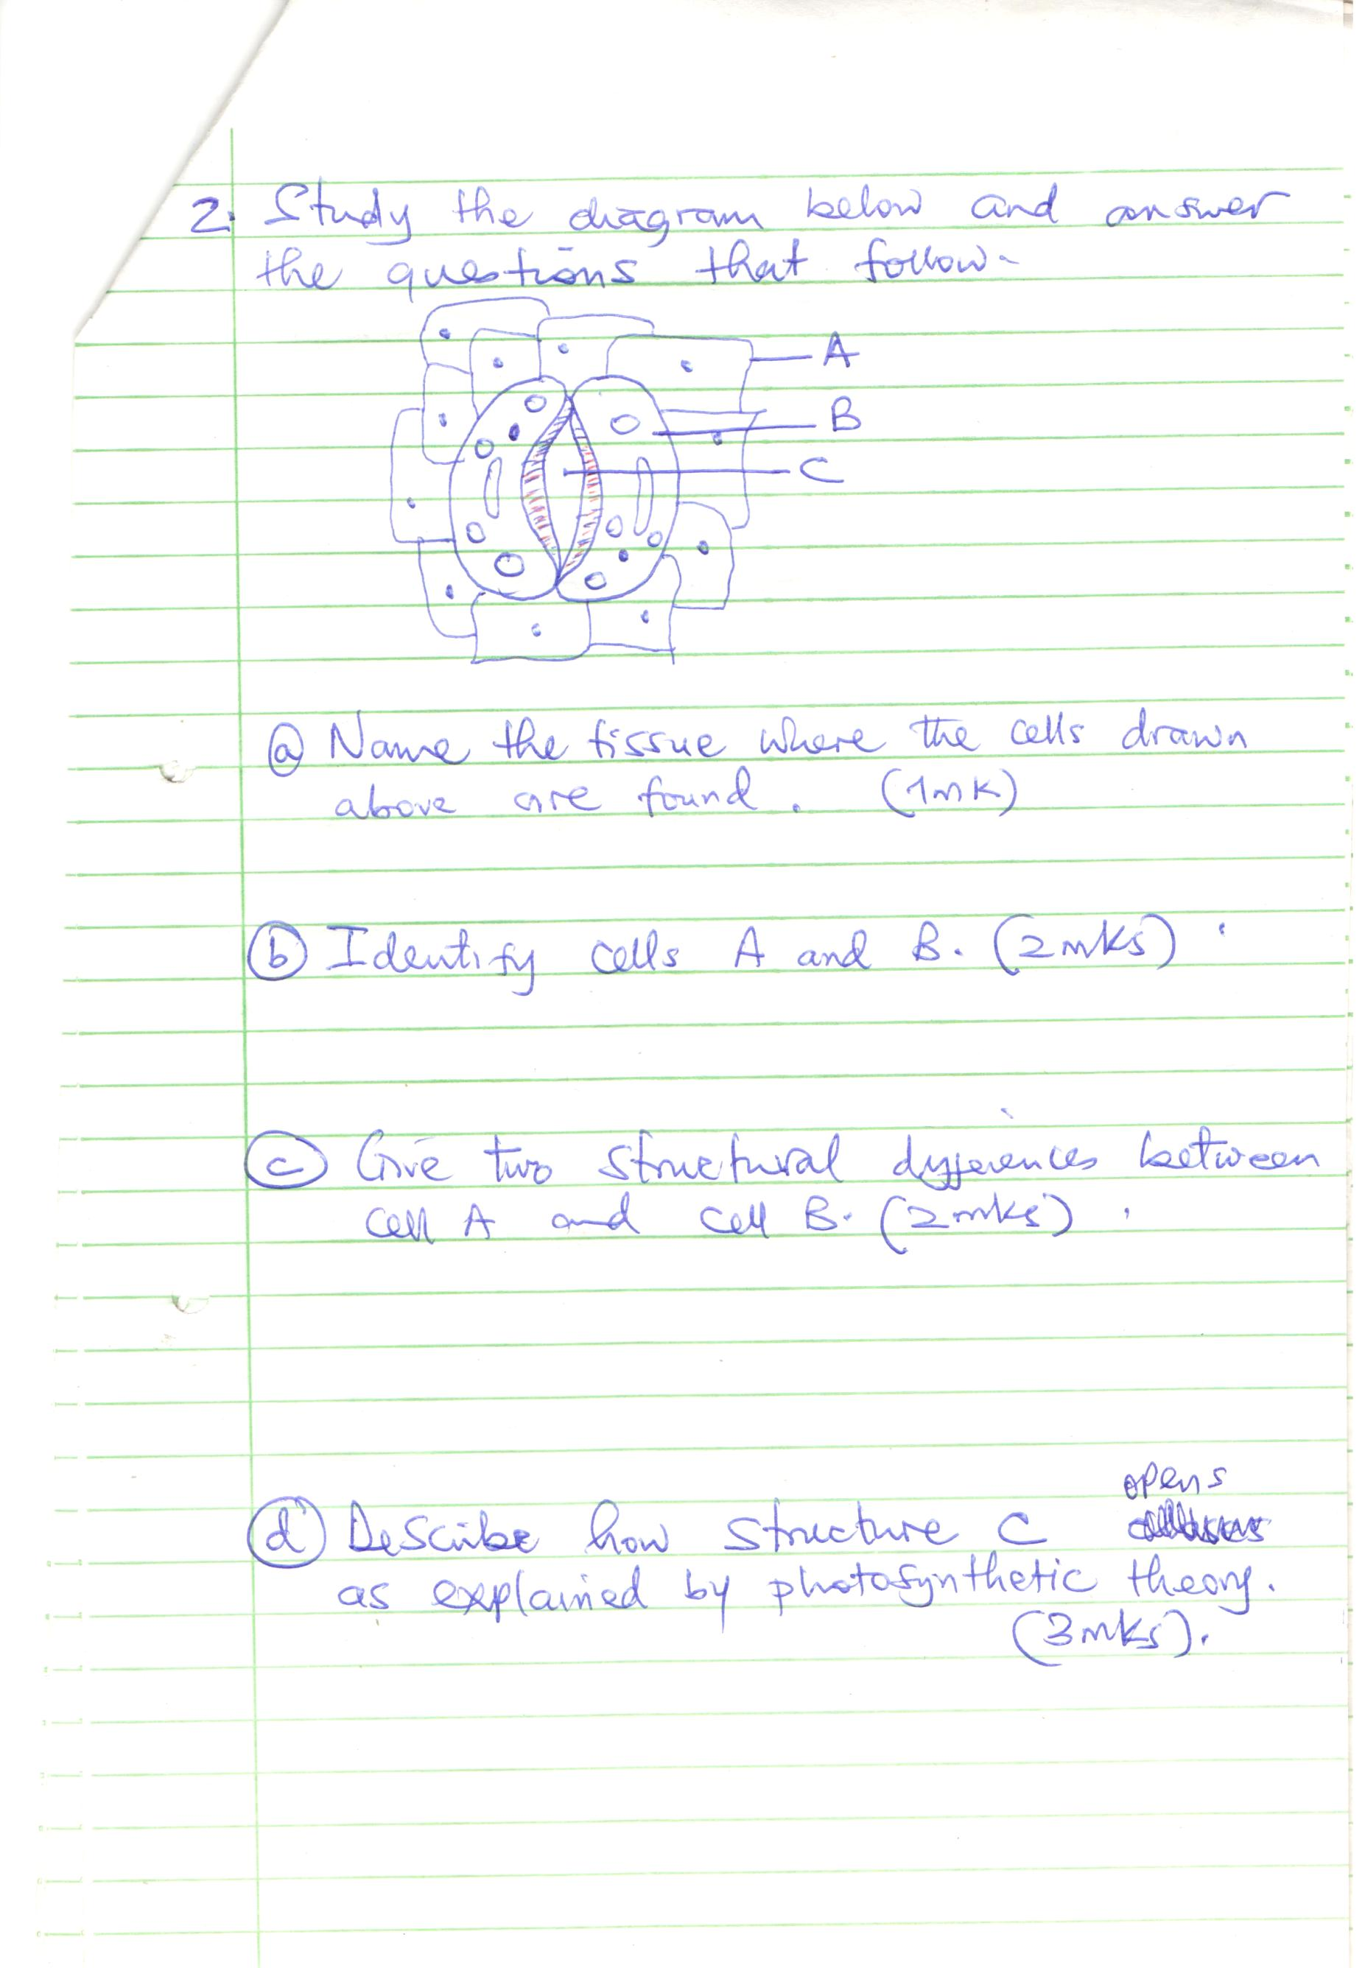

**C**

**B**

**A**

1. Name the tissue where the cells drawn above are found. **(1 mark)**

…………………………………………………………………………………………………

1. Identify cells A and B. **(2 marks)**

A………………………………………………………………………………………………………..

B………………………………………………………………………………………………………..

1. Give **two** structural differences between cell A and cell B. **(2 marks)**

…………………………………………………………………………………………………………………………………………………………………………………………………………………………………………………………………………………………………………………………………………………………………………………………………………………………………………

1. Describe how structure C opens as explained by the photosynthetic theory. **(3 marks)**

……………………………………………………………………………………………………………………………………………………………………………………………………………………………………………………………………………………………………………………………………………………………………………………………………………………………………………………………………………………………………………………………………………………………………………………………………………………………………………………………………………………………………………………………………………………………………………………………………………………………………………………………………………………

1. Catalase is an enzyme present in all living tissues in both plants and animals. It breaks down toxic hydrogen peroxide produced during cellular metabolism into less toxic water and oxygen is evidenced by effervescence.

In an experiment 10 ml of hydrogen peroxide was put in different boiling tubes into which different specimens were put. The table below summarizes part of the results. Carefully analyze the table and answer the questions that follow.

|  |  |  |
| --- | --- | --- |
|  | **The specimen** | **Observation** |
| A | Fresh liver | A lot of bubbling almost violent |
| B | Boiled liver | No bubbling |
| C | Fresh muscle tissue | Vigorous bubbling less than tube A |
| D | Dry bean seed | Very slow bubbling |
| E | Soaked bean seed | Vigorous bubbling done intensity of tube C |
| F | 1 cm3 potato cube | Moderate bubbling |
| G | 1 cm3 mashed potato | Vigorous bubbling since intensity as in tube E |

1. Compare & account for the rate of bubbling between

**(i)**Tube A and tube B. **(2 marks)**

………………………………………………………………………………………………………………………………………………………………………………………………………………………………………………………………………………………………………………………………………………

**(ii)**Tube A and C **(2 marks)** ……………………………………………………………………………………………………………………………………………………………………………………………………………………………….……………………………………………………………………………………………………………….

**(iii)**Tube D and tube E **(2 marks)**

………………………………………………………………………………………………………………………………………………………………………………………………………………………………………………………………………………………………………………………………………………

**(iv)**Tube F and G **(1 mark)**

………………………………………………………………………………………………………………………………………………………………………………………………………………………………………………………………………………………………………………………………………………

1. Write the equation for the reaction that produces the bubbling. **(1 mark)**

…………………………………………………………………………………………………………

1. The diagram below shows an instrument used in the laboratory.



(a) Name the apparatus shown above

…………………………………………………………………………… **(1 mark)**

(b) Name the parts labeled Q , K and R **(3 marks)**

**Q**……………………………………………………

**K**……………………………………………………

**R** …………………………………………………..

(c) What are the functions of parts **P, N** and **S.** **(3 marks)**

**P**……………………………………………………………………………………………………

**N**…………………………………………………………………………………………………..

**S**…………………………………………………………………………………………………….

(d) What is the formula of calculating linear magnification **(1 mark)**

………………………………………………………………………………………………………………………………………………………………………………………………………………

1. Diagram below represents a germinating seedling.



1. What is germination? **(1 mark)**

…………………………………………………………………………………………………………………………………………………………………………………………………………………..

1. Name the part labelled P, Q and R. **(3 marks)**

P………………………………………………………….

Q………………………………………………………….

R………………………………………………………….

1. Identify the type of germination shown in the diagram. **(1 mark)**

………………………………………………………………………………………………………...

1. What is the role of the following in germination of the above seedling?
2. Oxygen **(1 mark)**

…………………………………………………………………………………………………………2. Enzymes  **(1 mark)**

…………………………………………………………………………………………………………3. Water **(1 mark)**

…………………………………………………………………………………………………………………………………………………………………………………………………………………..

**SECTION B**

**Answer question 6 and either 7 or 8**

1. Some students used a model to demonstrate the effect of sweating on human body temperature. Two boiling tubes A and B were filled with hot water. The surface of tube A was continually wiped with a piece of cotton wool soaked in methylated spirit. The temperature of water in the tubes was taken at the start of the experiment and then at 5 minutes interval. The results obtained are as shown in the table below.

|  |  |  |
| --- | --- | --- |
| **Time (in minutes)** | **Temperature (oC) in tubes** | |
|  | A | B |
| 0 | 80 | 80 |
| 5 | 54 | 67 |
| 10 | 40 | 59 |
| 15 | 29 | 52 |
| 20 | 21 | 47 |
| 25 | 18 | 46 |

1. On the same axis plot graphs of temperature of water in the tubes against time. **(7 marks)**
2. At what rate was the water cooling in tube A? **(2 marks)**

……………………………………………………………………………………………………………………………………………………………………………………………………………………

1. Why was tube B included in the set up? **(1 mark)**

……………………………………………………………………………………………………………………………………………………………………………………………………………………

1. Account for the rate of cooling in tube A **(3 marks)**

……………………………………………………………………………………………………………………………………………………………………………………………………………………

1. State **two** processes of heat loss in tube B. **(2 marks)**

……………………………………………………………………………………………………………………………………………………………………………………………………………………

1. What would be the expected results if tube B was insulated? **(1 mark)**

………………………………………………………………………………………………………..

1. What would the insulation be compare to in

**(i)** Birds ? **(1 mark)**

…………………………………………………………………………………………………………

**(ii)** Mammals? **(1 mark)**

………………………………………………………………………………………………………..

1. Name the structures in the human body that detect

**(i)** External temperature changes **(1 mark)**

………………………………………………………………………………………………………..

**(ii)** Internal temperature changes **(1 mark)**

………………………………………………………………………………………………………..

1. (a) Differentiate between nervous system and endocrine system. **(5 marks)**
2. Describe how hormones regulate the menstrual cycle in human being. **(15 marks)**
3. How is the mammalian intestine adapted to its functions? **(20 marks)**