**FORM TWO MATHEMATICS**

**NAME…………………..………………………ADM………….CLASS…………….**

**SECTION 1 (50 MARKS)**

***Answer all questions in the spaces provided***

1. Use mathematical tables to evaluate; (4 marks)



2. The region R is the figure below is defined by the inequalities L1,L2 and L3.

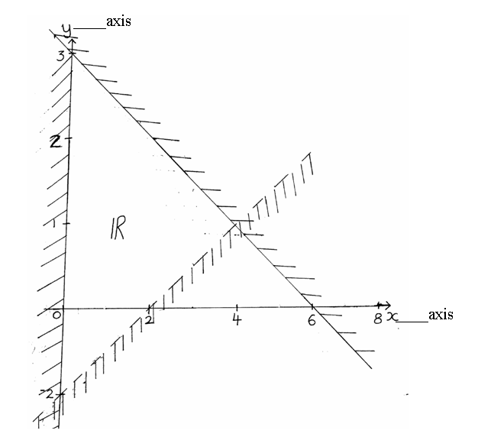

Find the three inequalities (3mks)

3. Without using a calculate, evaluate (3mks)



4. From a sector of a circle subtending an angle of 1500 and radius 14cm, a conical cup is made. Determinethe radius of the conical cup. (2mks)

5. Using a ruler and pair of compass only

a)Construct triangle ABC in which AB=4cm, angle ABC = 1200 and angle BCA =150(2mks)

b) Drop a perpendicular from A to meet CB produced at P. Measure AP. (2mks)

6. A rectangular tank of length 50 cm and width 30cm contains 36 litres of water.

Determine the height of water in the tank in cm (3mks)

7. The three sides of a right angled triangle are (x-1), (2x+8) and the hypotenuse (3x+1), find

the area of the triangle. (4mks)

8. Use reciprocal tables to find the value of (4mks)

correct to 4 s.f.

9.Given that sin , find tan (90 - ) in its simplest form (3mks)

10. Kagia is three times as old as his son now. If ten years ago the sun of their ages was 44. How old was Kagia when his son was born ? (3mks)

11.Twenty women working 12hours a day take 12 days to complete a job. How many more

Days will it take eight women working 20 hrs a day to complete the same job ? (3mks)

12. Find the non-zero scalar **β** and **µ** such that **βa**+**µb**=**c,** Given that

**a**= (3, 2), **b**= (4, 6) and **c**= (2, 2) (3mks)

13.A regular polygon has internal angle of 1500 and a side of length 10cm.

(a)Find the number of sides of the polygon (2mks)

(b)Find the perimeter of the polygon (1mk)

14. Solve for X in the equation; (2mks)



15.The angle of elevation of the top of a tower from a point x on the horizontal is 28.5.From another point y, 8 meters near to the base of the tower, the angle of elevation of the top of the tower is 37.20. Calculate, to one decimal place, the height of the tower. (3mks)

16.A line passes through the points A (2, 6) and B (4, -8). Find the equation of the perpendicular bisector of line AB. (3mks)

**SECTION B (20 MARKS)**

***Answer ONLY TWO questions in this section in the spaces provided***

17. A matatu left town A at 7:00 am and travelled towards town B at an average speed of of 60km/h. A second matatu left town B at 8:00am and travelled towards town A at 60km/h. If the distance between the two towns is 400km,Find:

a)The time at which the two matatus met. (7mks)

b) The distance of the meeting point from town A (3mks)

17.The figure below represents a frustum of a solid cone of base radius 48 cm and top radius 16 cm. The height of the frustum is 21 cm. (Taking  ) calculate:

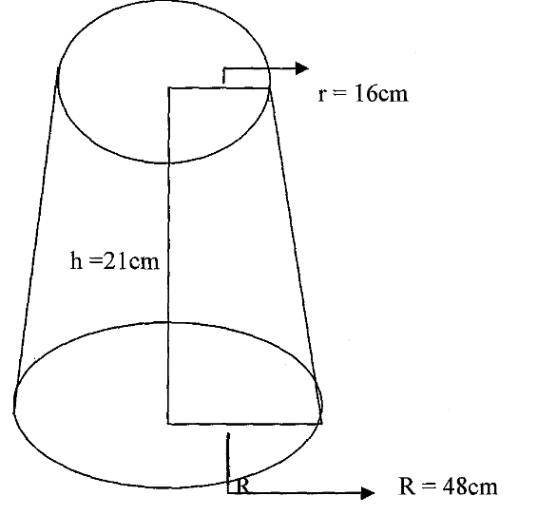

a) The height of the solid cone (2marks)

b) The volume of the solid frustum (3marks)

c) The total surface area of the frustum (5marks)

18.The table below shows the names of 200 persons measured to the nearest kg

|  |  |  |  |  |  |  |  |
| --- | --- | --- | --- | --- | --- | --- | --- |
| Mass  (kg) | 40-49 | 50-59 | 60-69 | 70-79 | 80-89 | 90-99 | 100-109 |
| No. of persons | 9 | 27 | 70 | 50 | 26 | 12 | 6 |

(a) Calculate the mean mass (5mks)

(b) Calculate the median mass (5mks)