Name:…………………………………………….. ….. Index No. ……………………….
School: ………………………………………… ……… Date: …………… Sign…………

FORM 4
232/2
PHYSICS
PAPER 2
TIME: 2 HOURS

Instructions to candidates;
- Write your name, index number and name of your school in the spaces provided.
- This paper consists of two parts A and B.
- Answer all questions in section A and B in the spaces provided.
- All working MUST be shown in the spaces provided after questions.
- Mathematical tables and electronic calculators may be used.
- Candidates should check the question paper to ascertain that ascertain that all the pages are printed as indicated and that no questions are missing.
For examiners use only
Section | Question | Maximum score | Candidates score
A | 1-12 | 25
B | 13 | 12
 | 14 | 14
 | 15 | 14
 | 16 | 15
 | Total score | 80

SECTION A (25mks)
Answer ALL questions in this section in the spaces provided after each question.
- What is the purpose of a fuse in domestic wiring system? (1mrk)
………………………………………………………………………………………………………………………………………………………………………………………………………………………………
- Use the domain theory to explain briefly why a ferromagnetic material gets saturated when magnetized. (2mks)
…………………………………………………………………………………………………………………………………………………………………………………………………………………………………………………………………………………………………………………………………………………………………………………………………………………………………………………….
- The figure 1 below shows an object placed some distance from a biconcave lens.

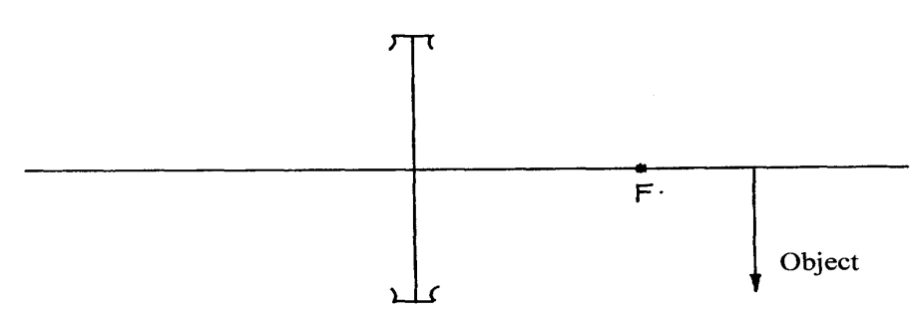
Figure 1
Construct the image on the diagram. (2mks)
- What determines the hardness of X-rays? (1mk)
…………………………………………………………………………………………………………………………………………………………………………………………………………………………
- Distinguish between the terms ‘photoelectric’ and ‘thermionic’ effect. (2mks)
………………………………………………………………………………………………………………………………………………………………………………………………………………………………………………………………………………………………………………………………………………………………………………………………………………………………………………………………

- The figure 2 below shows a light rod balanced due to the action of the forces shown. Q is a magnet of weight 4N and R is a permanent magnet which is fixed. Determine the force between Q and R and state whether it is attractive or repulsive. (3mks)

5cm 40cm
4N

20N

Q
R

Figure 2

………………………………………………………………………………………………………………………………………………………………………………………………………………………………………………………………………………………………………………………………………………………………………………………………………………………………………………………………………………………………………………………………………………………………………………………………………………………………………………………………………………………………..
- Determine the ammeter reading when the potential difference of 3.0 volts is supplied across PQ in figure 3. (3mks)
………………………………………………………………………………………………………………………………………………………………………………………………………………………………………………………………………………………………………………………………………………………………………………………………………………………………………………………………………………………………………………………………………………………………………………………………………………………………………………………………………………………………

- The chart below shows an arrangement of different parts of the electromagnetic spectrum.
Name the possible radiations represented by letter B. (1mk)
……………………………………………………………………………………………………………
- A student stands at a distance 400m from a wall and claps two pieces of wood. After the first clap the student claps whenever an echo is heard from the wall. Another student starts a stopwatch at the first clap and stops it after the twentieth clap. The stopwatch records a time of 50 seconds. Find the speed of sound. (3maks)
……………………………………………………………………………………………………………………………………………………………………………………………………………………………………………………………………………………………………………………………………………………………………………………………………………………………………………………………
……………………………………………………………………………………………………………………………………………………………………………………………………………………………………………………………………………………………………………………………………………….
- The figure 4 below shows a plane mirror KL and an object B.
K
Object B

Eye L
Figure 4
- Complete the ray diagram to show how the person sees the image. (2mks)

- State the nature of the image formed. (2mks)
…………………………………………………………………………………………………………………………………………………………………………………………………………………………

- The following equation represents a decay series.
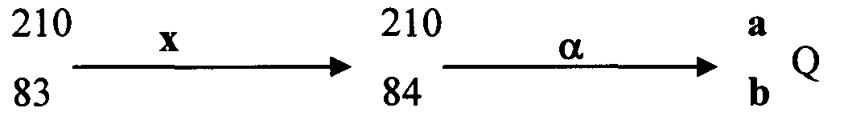

Identify the radiation x and determine the values of a and b. (2mks)
………………………………………………………………………………………………………………………………………………………………………………………………………………………………………………………………………………………………………………………………………
- A gold leaf electroscope is positively charged as shown in the diagram below where C is the cap and L is the gold leaf. State and explain what happens to L when a positively charged rod is brought near C without touching it. (2mks)
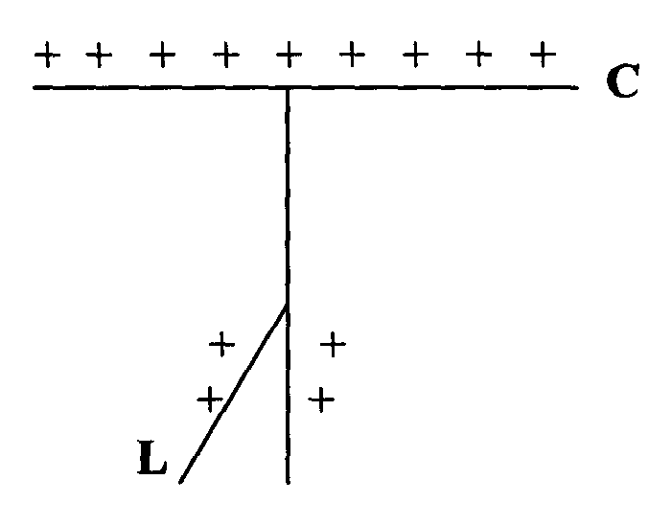
…………………………………………………………………………………………………………………………………………………………………………………………………………………………………………………………………………………………………………………………………………………………………………………………………………………………………………………….
SECTION B (55 MARKS)
Answer ALL questions in this section in the spaces provided after each question.
- a) Differentiate between transverse and longitudinal waves. (2mks)
b) Figure 5 shows a transverse stationary wave along a string
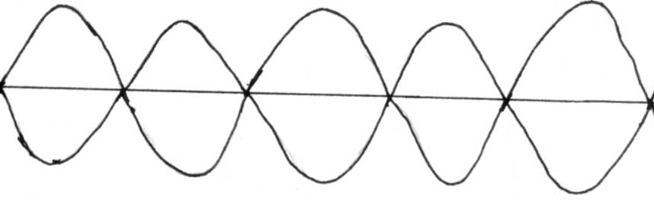

Figure 5
i). Label the nodes and antinodes on the diagram above. (2mks)
ii). If the distance between an anti-node and consecutive node is 1.0 x 10⁻³m, determine the wavelength of the stationary wave. (2mks)
……………………………………………………………………………………………………………………………………………………………………………………………………………………………………………………………………………………………………………………………………………………………………………………………………………………………………………………
c). Five successive wave frequency in a ripple tank are observed to spread a distance of 6.4cm. If the vibrator has a frequency of 8 Hz, determine the speed of the wave. (3mks)
……………………………………………………………………………………………………………………………………………………………………………………………………………………………………………………………………………………………………………………………………………………………………………………………………………………………………………………
d). The figure 6 below shows a displacement-time graph for a wave motion
Figure 6
What is the frequency of the wave? (3marks)
……………………………………………………………………………………………………………………………………………………………………………………………………………………………………………………………………………………………………………………………………………………………………………………………………………………………………………………………………………………………………………………………………………………………………….
- (a) What do you understand by the term e.m.f of a cell?. (1mk)
………………………………………………………………………………………………………………………………………………………………………………………………………………………………
(b) A cell of e.m.f E and internal resistance r is used to pass a current through various resistors R Ohms and the values of current recorded in the table below.
R(Ohms) | 1.6 | 2.1 | 2.5 | 3.6 | 5.0 | 8.0
I(A) | 1.0 | 0.8 | 0.7 | 0.5 | 0.37 | 0.34
1/i(A⁻¹)

i. Complete the table for the values of 1/i giving your answer to 3d.p. (3mks)
ii. Plot a graph of 1/i versus R. (5mks)

iii. Given that the equation E =I(R +r), use your graph to determine the values of E and r. (5mks)
…………………………………………………………………………………………………………………………………………………………………………………………………………………………………………………………………………………………………………………………………………………………………………………………………………………………………………………………………………………………………………………………………………………………………………………………………………………………
- a) State three factors that determine the capacitance of a parallel plate capacitor. (3marks)
………………………………………………………………………………………………………………………………………………………………………………………………………………………………………………………………………………………………………………………………………………
b) Three capacitors of capacitance 200µƒ, 300µF and 600µƒ are connected together in a circuit.
- Draw a circuit diagram to show the arrangement of the capacitors which gives an effective capacitance of 100µƒ. (2marks)

c) The figure 6 below shows a circuit where a battery of e.m.f 6V , switches X and
Y, two capacitors of capacitance 2 µF and 4 µFare connected.
6V

X

Y
2µF

4 µF
Figure 6

- Determine the charge stored in the 2 µF capacitor when switch X is closed and switch Y is open. (3marks)
………………………………………………………………………………………………………………………………………………………………………………………………………………………………………………………………………………………………………………………………………………………………………………………………………………………………………………………………

- When switch Y is finally closed and switch X is open, determine the potential difference across each capacitor. (3marks)
………………………………………………………………………………………………………………………………………………………………………………………………………………………………………………………………………………………………………………………………………………………………………………………………………………………………………………………………………………………………………………………………………………………………………………..
- Briefly explain how the lightening arrester works. (3mks)
………………………………………………………………………………………………………………………………………………………………………………………………………………………………………………………………………………………………………………………………………………………………………………………………………………………………………………………………………………………………………………………………………………………………………………
- (a) Define the term ‘work function’. (1mk)
………………………………………………………………………………………………………………………………………………………………………………………………………………………………………………………………………………………………………………………………………
(b) List three factors which affect photoelectric effects. (3mks)
……………………………………………………………………………………………………………………………………………………………………………………………………………………………………………………………………………………………………………………………………………….
(c) The table below shows the stopping potential and the corresponding frequencies for a certain photocell.
Stopping potential V_{s} (V) | 0.2 | 0.6 | 1.10 | 1.42 | 1.83
Frequency f (×10¹⁴Hz) | 4.0 | 5.0 | 6.0 | 7.0 | 8.0
Plot a graph of stopping potential against frequency. (5mks)

Use your graph to determine;
- The threshold frequency.(2mks)
………………………………………………………………………………………………………………………………………………………………………………………………………………………………………………………………………………………………………………………………………………………………………………………………………………………………………………………………
- Plank’s constant. (Take e to be 1.6×10⁻¹⁹C) (2mks)
………………………………………………………………………………………………………………………………………………………………………………………………………………………………………………………………………………………………………………………………………………………………………………………………………………………………………………………………
- Work function. (2mk)
………………………………………………………………………………………………………………………………………………………………………………………………………………………………………………………………………………………………………………………………………………………………………………………………………………………………………………………………………………………………………………………………………………………………………………………………………………………………………………………………………………………………..

