NAME ____________________________________ INDEX NO. _______________
SCHOOL ____________________________________ SIGNATURE _______________ DATE _______________

312/1
GEOGRAPHY

PAPER 1

TIME: 2¾ HOURS
FORM 4

312/1
GEOGRAPHY
PAPER 1
TIME: 2¾ HOURS

INSTRUCTIONS TO CANDIDATES
- This paper has two sections: A and B.
- Answer all the questions in section A.
- Answer question 6 and any other two questions from Section B.
- All answers must be written in the answer booklet provided.
- This paper consists of 4 printed pages.
- Candidates should check the question paper to ascertain that all pages are printed as indicated and that no questions are missing.
- Candidates should answer the questions in English.

SECTION A
Answer ALL the questions in this section.
- a) What does the word ‘Geo’ mean? (1 mark)
b) Give four areas of great interest to a physical geographer. (4 marks)

- a) Name two plains found in Kenya. (2 marks)
b) State three ways in which plains are formed. (3 marks)

- a) Identify two types of local winds. (2 marks)
b) Describe briefly how a land breeze occurs. (3 marks)

- a) Define river capture. (2 marks)
b) List three evidences of river capture. (3 marks)

- The diagram below shows a barchan.
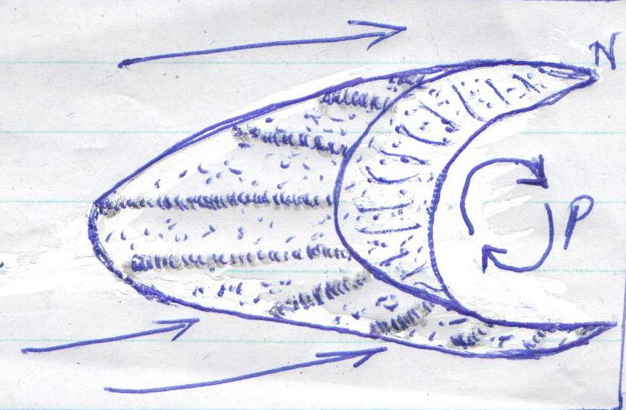
N
P

- Name the feature marked N. (1 mark)
- Name the air currents marked P. (1 mark)
- Describe how a barchan is formed. (3 marks)

SECTION B
Answer question 6 and any other two questions from this section.
- Study the map of Migwani 1:50,000 (sheet 151/1) provided and answer the following questions.
- i) What type of map is Migwani map extract? (2 marks)
- What is the height of the highest point on the area covered by the map? (2 marks)
- Identify two types of natural vegetation on the area covered by the map. (2 marks)
- Determine the direction and bearing of Kauma dam from Usiani school. (3 marks)

- Draw a square 14cm by 14cm to represent the area shown on the map between easting
06 and 13 and northing 77 and 84. (1 mark)
On the square, mark and name the following:
- Dry weather road (1 mark)
- Mboni dam (1 mark)
- Water pipeline (1 mark)
- River Ngoo (1 mark)
- i) Using evidence from the map, describe the climate of the area. (4 marks)
ii) What two problems do the climatic conditions you have described above pose to
the area? (2 marks)
iii) Citing evidence from the map, mention two attempts that have been made to solve the
problems above. (2 marks)
- Describe the topography of the region shown on the map. (3 marks)

- a) i) Describe how a tarn is formed. (4 marks)
ii) Name two areas in East Africa where tarns are found. (2 marks)
b) State five external land forming processes that lead to formation of lakes. (5 marks)
- Explain the effects of each of the following on lakes in Kenya:
- Deforestation (2 marks)
- Industrialization (2 marks)
- Waterweeds (2 marks)
- Explain four ways by which human activities threaten the existence of lakes in Kenya. (8 marks)

- a) i) Distinguish between a spring and a well. (2 marks)
- State three sources of underground water. (3 marks)
- Explain how the following factors influence the existence of underground water.
- nature of rocks (2 marks)
- vegetation cover (2 marks)
- i) What is an artesian well? (1 mark)
ii) Explain three conditions which are ideal for the formation of artesian wells. (6 marks)
- Draw a neat diagram of an artesian basin and on it mark and name the following. (2 marks)
- The water-intake area (1 mark)
- An aquifer (1 mark)
- The impermeable rock (1 mark)
- Explain two problems associated with artesian wells. (4 marks)

a) i) State three factors which cause soil creep. (3 marks)
- describe four effects of soil creep. (4 marks)
- i) State two conditions which may influence the occurrence of landslides. (2 marks)
ii) Name three forms of landslides. (3 marks)
iii) Apart from landslides, name two other forms of rapid mass wasting. (2 marks)
- The diagram below shows mass movement on a slope.
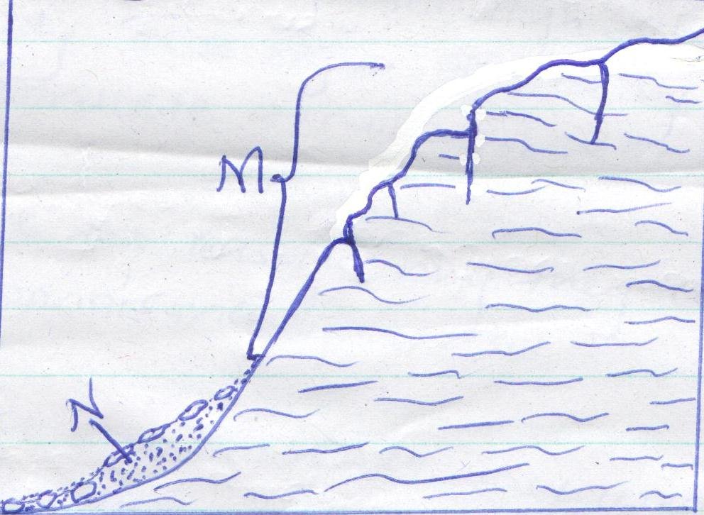
N
M
Name the:
- Type of mass movement shown. (1 mark)
- Features M and N. (2 marks)
- Explain four effects of mass wasting on the physical environment. (8 marks)

- a) i) What is an earthquake? (2 marks)
ii) Explain three causes of earthquakes (6 marks)
b) i) Using an illustration distinguish between seismic focus and epicentre. (4 marks)
ii) Name two types of earthquakes waves. (2 marks)
c) Student from Magomani High School carried out a field study in a region affected by
earthquakes.
i) Formulate a null hypothesis for their study. (1 mark)
ii) State two reasons why they conducted a reconnaissance (pre-visit). (2 marks)
iii) List two methods they used to record data during the study. (2 marks)
d) Explain three effects of earthquakes on the human environment. (6 marks)

