NAME ……………………………………… INDEX……………............................
CLASS………………....................................

231/1
BIOLOGY
PAPER 3
PRACTICAL
1 ¾ HOURS

FORM 4

Answer all questions
FOR EXAMINORS ONLY
Question | Maximum Score | Candidates score
1-3 | 40

Candidates should check the question paper to ensure that all the pages are printed as indicated and no questions are missing.

1. Study the photographs given below to answer the questions that follow

(a) You are provided with photographs of specimens labeled X, Y and Q . Study them carefully and answer the questions that follow.
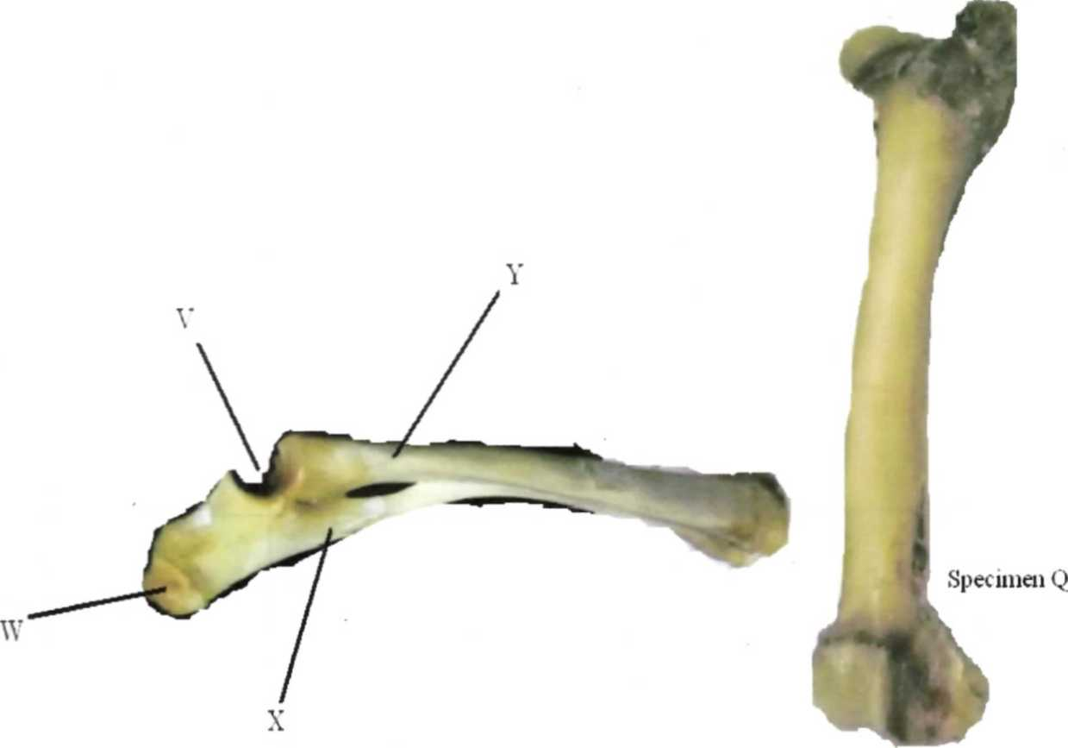

Identify the specimen
X........................................................................

Y......................................................................

(b) Name the part (Description) of the mammalian body from which the specimen X was
obtained (1 mark)
............................................................................................................................................................
(c) With reasons name the type of joint formed at the Proximal and distal ends of specimen Q
Proximal end (1 mark)
........................................................................................................................................................
Reason (1 mark)
....................................................................................................................................................................................................................................................................................................................................
Distal end (1 mark)
....................................................................................................................................................
Reason (1 mark)
..................................................................................................................................................................................................................................................................................................................
d) (i) What is the significance of the part labeled W? (2 marks)
........................................................................................................................................................................................................................................................................................................................................................................................................................................................................................................................................................................................................................................................................
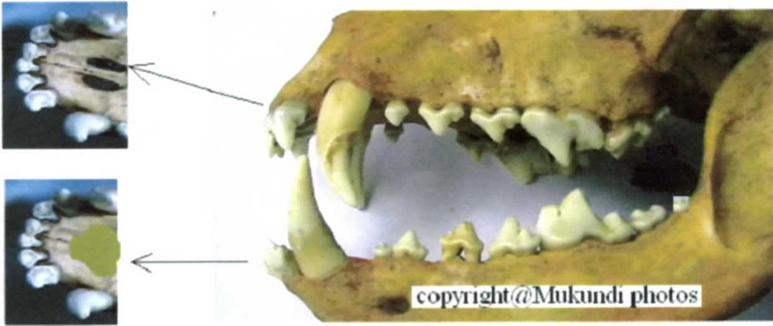
(ii) The photograph below labeled P was obtained from a certain mammal.

Giving reasons, state the diet of the animal whose skull is shown in the photographs. (2 marks)
Diet
............................................................................................................................................................
Reason(s)
........................................................................................................................................................................................................................................................................................................................................................................................................................................................................................................................................................................................................................................................................
(e) Label the canine tooth in photograph Q. (1 mark)
(f) Write the dental formula of the animal whose skulls is shown in photographs Q. (1 mark)

(g) In the photograph show the carnassials teeth and state one ways in which they are adapted to
their function. (3 marks)
........................................................................................................................................................................................................................................................................................................................................................................................................................................................................................................................................................................................................................................................................
....................................................................................................................................................................................................................................................................................................................................
2. You are provide with
Specimen S1
Specimen T1
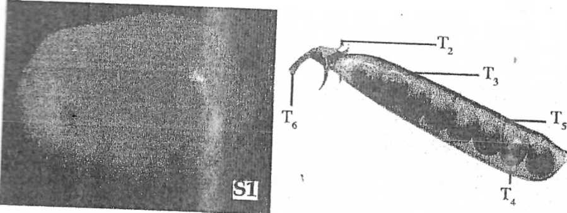

T1
(a) Specimen SI was cut longitudinally as shown below.
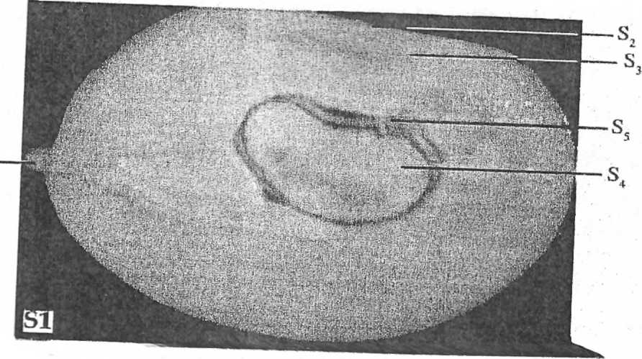

I Name the parts labelled S₂ S₃ S₄ and S₅
.......................................................................................................................................................................................................................................................................................................................................................................................................................................................................................................................................................................................................................................................................
....................................................................................................................................................................................................................................................................................................................................
II Using photograph T_{2,} T₃T₄and T₅
List five differences between specimen S1 and T1
Specimen S1 | Specimen T1

b. (i) Complete the following table showing the type of fruit and reasons for each answer
(6 marks)
Specimen S1 | Type of fruit | Reasons

(ii) Complete the following the method of dispersal and reasons for each answer
Specimen | Method of dispersal | Reasons
S1
T1

3. Meiosis occurs in two nuclear divisions. State what happens during the first and the second nuclear divisions stages
a) 1st division _________________________ 2nd __________________________ (2 marks)
b) Identify the following stages of meiosis 1. (4 marks)
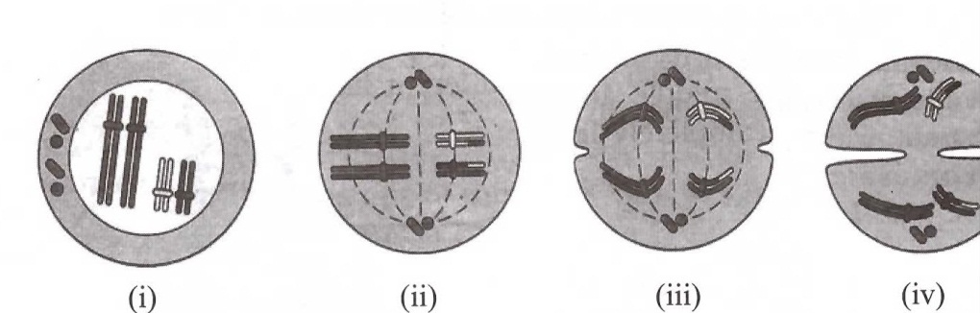

c) During what stage of meiosis does synapsis occur (1 mark)
......................................................................................................................................................
d) State the significance of the event mentioned (1 mark)
.......................................................................................................................................................................................................................................................................................................................................................................................................................................................................................................................................................................................................................................................................
....................................................................................................................................................................................................................................................................................................................................

